TYPE I - RENEWABLE ENERGY PROJECTS

Note: Categories I.A, I.B and I.C involve renewable energy technologies that supply electricity, mechanical and thermal energy, respectively, to the user directly. Renewable energy technologies that supply electricity to a grid fall into category I.D.

Follow the link to find General guidance / Abbreviations

I.E. Switch from Non-Renewable Biomass for Thermal Applications by the User

Technology/ Measure

- This category comprises of small appliances involving the switch from non-renewable biomass to renewable sources of energy. These technologies include biogas stoves, use of solar cookers and measures that involve the switch to renewable biomass.

Note: similar methodologies should be drafted for
  - energy efficiency improvements in the use of non-renewable biomass
  - replacement of non-renewable biomass with energy efficient fossil fuels,
using the principles outlined below (use of fossil-fuel emission factors in the baseline; use of actual conversion efficiencies of non-renewable biomass in the baseline).

Boundary

- The project boundary is the physical, geographical area of the use of non-renewable biomass or the renewable energy.

Baseline

- For the purpose of estimating emission factors in the baseline, t is assumed that in the absence of the project activity, the baseline scenario would be the use of fossil fuel commonly observed with local consumers, for meeting similar thermal energy needs. When calculating conversion efficiencies in the baseline, consideration is given to the characteristics of the conversion equipment (such as solid-fuel stoves) with which the non-renewable biomass is utilized.

Demonstrating that biomass in the baseline is non-renewable

Project proponents must demonstrate that the biomass used in the baseline is indeed non-renewable, following the EB 23 Annex 18 definition of “renewable biomass” (by inversion). One option is for project proponents to demonstrate that the amount of fuelwood or charcoal available in the project area is diminishing, thus demonstrating that carbon stocks are being depleted. For example, if the transport distance to obtain fuelwood is demonstrably and verifiably increasing over time, biomass can be assumed to be non-renewable.

Another option is to apply a quantitative assessment, using the following steps:
Step 1: identify a “woody biomass production area” (area) which should the larger of the following two areas: a) all forests and woodlands from which the project participants derive their wood fuel in the baseline, b) all forests and woodlands from which project participants could realistically obtain biomass, given means of transport, acessability and daily time available for transporting biomass.
Step 2: For the area estimated in step 1, estimate the average annual wood fuel increment (I) which could be harvested, consistent with the definition of “renewable biomass”. For this purpose, tools like satellite data, regional or IPCC allometric equations to estimate the above ground biomass increment etc. may be used.
Step 3: estimate the average harvest of wood fuels derived from this area (H)
Step 4: calculate the shortage of woody biomass in the area: S = H – I.
Step 5: Demonstrate that the amount of woody biomass used in the project baseline, at time zero, is less than S. If this is not the case, set the amount of woody biomass that can be included in the baseline to S.
Step 6: Demonstrate that the type of wood-based biomass occurring in the baseline (e.g., cooking fuel) is a significant share [20%] of H in the area analysed. That is, use for cooking fuel (in this example) is a significant end-use category.

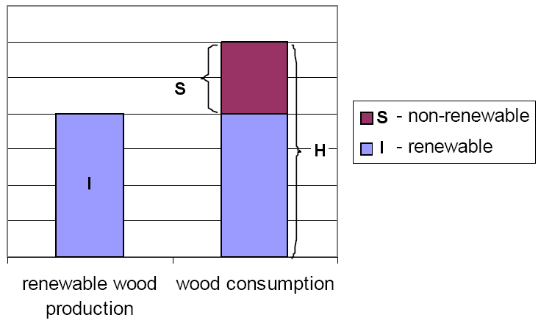

Where,
A | Area from which woody biomass is produced (the larger of the following two areas: a) all forests and woodlands from which the project participants derive their wood fuel in the baseline, b) all forests and woodlands from which project participants could realistically obtain biomass, given means of transport, acessability, and daily time available for transporting biomass).
I | Annual biomass increment (tons/year) on area A
H | Annual biomass harvest (tons/year) on area A
S | Net shortage of wood on area A.

To avoid incentives for enhancing deforestation and forest degradation in order to meet the conditions of “non-renewable biomass”, project proponents can only claim emission reduction from the total amount biomass that could be defined as non-renewable at the time of, or before, the adoption of this methodology (e.g., December 2007).

Emission Reductions

- Emission reductions would be calculated as:

ER_{y} = B_{y} · NCV_{biomass} · ${\text{EF}}_{\text{CO2, fossil}}$

where:
ERy Emission reductions during the year y in t CO₂
By Quantity of non-renewable biomass that is substituted or displaced in tonnes, calculated as:

- the product of the number of appliances multiplied by the estimate of average annual consumption of non-renewable biomass per appliance (tonnes/year). This can be derived from historical data or a survey of local usage.

OR

- The quantity of renewable biomass used in the project activity corrected for differences in calorific values.

NCV biomass Net calorific value of the non-renewable biomass that is substituted (IPCC default for wood fuel, 15 MJ/Kg)

$${\text{EF}}_{\text{non-renewablebiomass,CO2}}=\frac{e_{\text{stoves,biomass}}}{e_{\text{stoves,fossil }}}⋅{\text{EF}}_{\text{CO2, fossil}}$$

EFCO2, fossil CO2 emission factor for the fossil fuel; 71.5 tCO2/TJ for Kerosene, 63.0 tCO2/TJ for LPG or the IPCC default value of the fossil fuel commonly observed with local consumers
Leakage

- Leakage will be addressed by deducting 15% of the generated emissions reductions.

Monitoring

- Monitoring shall consist of an annual check of all appliances or a representative sample thereof to ensure that they are still operating or replaced by an equivalent in service appliance.

- Monitoring should confirm the complete displacement or substitution of the non-renewable biomass at each location. In the case of appliances switching to renewable biomass the quantity of renewable biomass used shall be monitored.

