Inputs on “Draft general guidance on sampling and surveys for SSC projects”

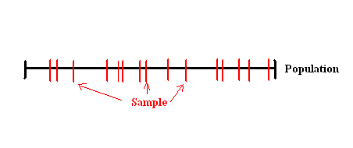
For a better and easier understanding of the different sample types, charts could be provided. :

Simple Random Sample – p. 13 paragraph 12.

1- Simple random sample

A reference to the Annex 1 could be provided : “For more details about the sampling formulas for simple Random, see p.11 to p.14 in the Annex 1.”

Systematic sampling – p. 4

For more accuracy, “in which every kth element in the frame is selected” could be replaced by in which every p.k th element in the frame is selected, where$p∈\left\{1,\text{.}\text{.}\text{.},n\right\}$”
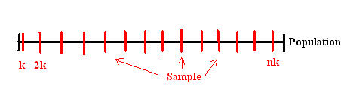
2 - Systematic sampling

A reference to the Annex 1 could be provided : “For more details about the sampling formulas for systematic Random, see p.14 to p.15 in the Annex 1.”

Stratified Random sampling – p. 4

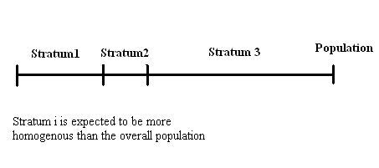

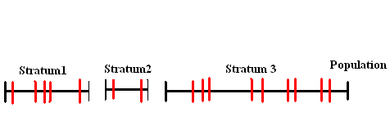
- Random sampling in each stratum (sample: red; population: black)

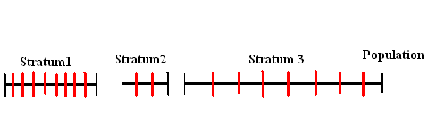

- Systematic sampling in each stratum (sample: red; population: black)

Cluster sampling – p. 5

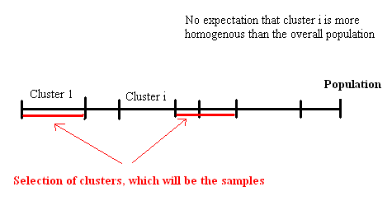

Multi-stage sampling – p.5 -6

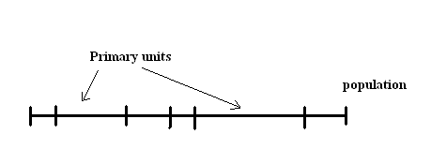
- selection of primary units

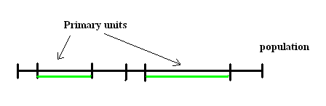
- selection of secondary units -> sample

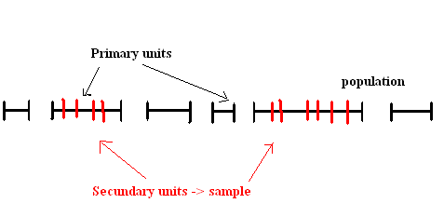
p. 9 - 42. Desired Precision/Expected Variance and Sample Size

For a better understanding, references to Annex 1 could be given:

- “(critical t value of 1.64)” could be replaced by “(critical t value of 1.64 – see Annex 1 p.12 paragraph 5.)”
- “(equals .2×.8×(1.64/.02)2 )” could be replaced by
“Indeed, $\text{1076}=\frac{s^{2}\text{.}t^{2}}{l_{t}^{2}}=\frac{(0\text{.}2x0\text{.}8)\text{.}1\text{.}{\text{64}}^{2}}{0\text{.}{\text{02}}^{2}}$ (see annex 1 – p. 13 – paragraph 8.)
Where : $s^{2}$= 20% x (1 -20%) (see Annex 1 p. 13 paragraph 9.)
t = 1.64 (see Annex 1 p.12 paragraph 5.)
$l_{t}$= 2%”
In order to remove any possible confusion, information shoud be precised :

- “26902.5 x 0.2 x 0.8 x (1.64/0.02) 2 »
- « 450 (448 = 2690/6)”

p. 10 - 43.

- Does “=/-“ mean ”+/-“ ?
- In order to remove any possible confusion, information shoud be precised :
“Based on this, the target precision bound is =/- 125 hours per year (125 = 10% x 1250)”.
“Previous studies of residential lighting usage have found that the standard deviation of usage is on the order of 500 hours per year, which implies that 95% of usage (critical t value of 1.96 – see Annex 1 p.12 paragraph 5.) lies in the range of 1250 +/- (1.96 x 500) i.e. 250 to 2250 hours per year.
“The sample size needed to estimate the hours of usage within the target range at a 90% confidence level is less than 50 (equals $\frac{s^{2}\text{.}t^{2}}{l_{t}^{2}}$= (500×1.64/125)2 = 43 - see Annex 1 – p. 13 – paragraph 8.).’

p.11 Annex 1 – Definitions

- Error in the definition of the mean $\overline{Y}$: $\overline{Y}=\frac{1}{N}\sum_{i=1}^{N}{y_{i}}$
Remark: the footnote could be placed as follows to avoid possible confusion with a square: “$\overline{Y}$ denotes the population mean ² of y”

- The usual definition of the true variance is $S^{2}=\frac{1}{N}\sum{{(y_{i}−\overline{Y})}^{2}}$. The factor (n-1) is only used when the variable is an estimation of the true value. Indeed, in the case of an estimation, the factor (n-1) is used so that the variation become an unbiased estimator of the true population variance (for more details, see http://www.quickmba.com/stats/standard-deviation/ and calculation section “Population variance and sample variance” of http://en.wikipedia.org/wiki/Variance)

- Error in the notation p.12 (3.)
As the variance is the sample variance the notation should be $s^{2}$ and not $S^{2}$(true population variance): $s^{2}=\frac{1}{n−1}\sum{{(y_{i}−\overline{y})}^{2}}$

- As the “standard error” is also called later in the document “standard deviation”, both names should be given in the definition :
“The standard error of y (also called standard deviation) denoted by the symbol s, is simply its square root.”

- For more accuracy and precisions, p. 12 paragraph 5.:
Under the fairly mild assumption that $\overline{y}$ is normally distributed, which “is adequate in
most practical situations”7, one can state the probability Prob(t) that $\overline{y}$ falls within a specified range of the population mean.
Indeed, then $\frac{\overline{y}−\overline{Y}}{S_{\overline{y}}}$follows a standard normal distribution, as in the chart below:
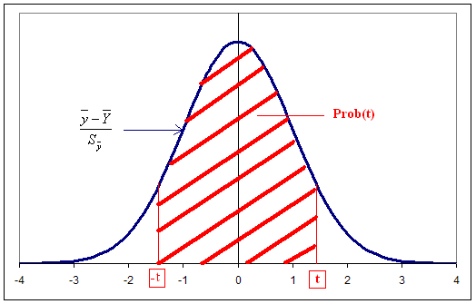

Where t is the normal deviate corresponding to Prob(t), i.e., the percentage of the normal probability density that falls within t standard deviations of the mean.

And so:
$$\text{Pr}\text{ob}(t)=\text{Pr}\text{ob}\left\{−t≤\frac{\overline{y}−\overline{Y}}{S_{\overline{y}}}≤t\right\}=\text{Pr}\text{ob}\left\{\overline{Y}−{\text{tS}}_{\overline{y}}≤\overline{y}≤\overline{Y}+{\text{tS}}_{\overline{y}}\right\}$$
Finally, we have the following formula:

$$\text{Pr}\text{ob}(t)=\text{Pr}\text{ob}\left\{\overline{Y}−\frac{\text{ts}}{\sqrt{n}}\sqrt{1−n/N}≤\overline{y}≤\overline{Y}+\frac{\text{ts}}{\sqrt{n}}\sqrt{1−n/N}\right\}$$
i.e. $\text{Pr}\text{ob}(t)=\text{Pr}\text{ob}\left\{\overline{Y}−l_{t}≤\overline{y}≤\overline{Y}+l_{t}\right\}$
or $\text{Pr}\text{ob}(t)=\text{Pr}\text{ob}\left\{\overline{Y}(1−\text{pct})≤\overline{y}≤\overline{Y}(1+\text{pct})\right\}$
Where $l_{t}$ = $\frac{\text{ts}}{\sqrt{n}}\sqrt{1−n/N}$
$\text{pct}=\frac{l_{t}}{\overline{Y}}$
So that one can state the probability that $\overline{y}$ falls within a specified range of the population mean.

Indeed knowing the probability Prob(t) that $\overline{y}$ falls within a specified range of the population mean, we can determine t (and vice versa), using the flowing table:

Here are some examples of normal deviates t:
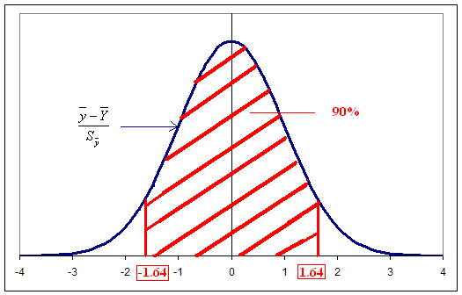
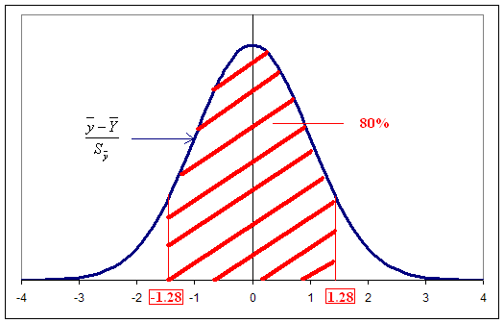

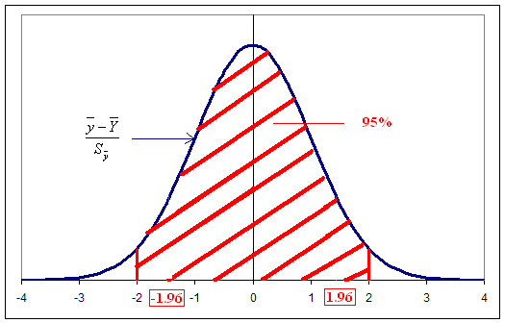

6. One could reformulate the 6. in this way:

“6. The formula also provides the basis for specifying the size of a sample, given a target level of precision for the estimate of the mean value and a prior estimate of the variance in the variable of interest in the population. Suppose, for example, that one wished to estimate the average operating hours with a precision of ± $l_{t}$ = ± 100 hours per year, with a confidence of Prob(t)=90%. Further suppose that previous studies showed that the standard deviation s of operating hours in the population is on the order of s = 500 hours. (For the purpose of this example, assume that the population (N) is large, so that one can ignore the term 1− n / N , known as the finite population correction term or fpc.)
We have the following formula : $l_{t}$ = $\frac{\text{ts}}{\sqrt{n}}\sqrt{1−n/N}≈\frac{\text{ts}}{\sqrt{n}}$ (see Annex 1 5.)
i.e. n=$\frac{(t\text{.}s)^{2}}{l_{t^{2}}}$
Given that the sample estimates of the mean are approximately normally distributed, Prob(t)=90% of its density falls within t=1.64 standard deviations of its mean. Solving for the value of n results in a sample size of 67.24. Rounding up to the nearest whole number, a sample of 68 will produce an estimate of the operation hours that lies within 100 of the true population average over 90% of the time.”

7. For more homogenous notations : Sy should be replaced by s, tcrit by t, P by Prob(t) :
“The formula for the required minimum sample size (nmin ) to estimate the mean value of a
variable ($\overline{y}$) within an interval (l t ) at a designated probability P, where t is the t value
corresponding to Prob(t), is given by:
$n_{\text{min}}=\frac{t^{2}\text{.}s^{2}}{(l_{t}^{2}+s^{2}\text{.}\frac{t^{2}}{N})}$ “

8. Same comments.
“The second term in the denominator,$s^{2}\text{.}\frac{t^{2}}{N}$, approaches zero for a large population, so that the formula can be approximated by: $n_{\text{min}}=\frac{t^{2}\text{.}s^{2}}{l_{t}^{2}}$”

9. Error in the calculation of the variance and clarifications:
“When the variable of interest is binary (yes/no), the variance $s^{2}$ is simply the frequency $P_{\text{yes}}$
(percent “yes”) times the frequency $P_{\text{no}}$ (percent “no”) i.e.

$$s^{2}=P_{\text{yes}}\text{.}P_{\text{no}}=P_{\text{yes}}\text{.}(1−P_{\text{yes}})=(1−P_{\text{no}})\text{.}P_{\text{no}}$$
as $P_{\text{yes}}=1−P_{\text{no}}$for a binary variable

That would be the case, for example, in estimating the attrition rate of installed equipment, where “yes” indicates the equipment was removed and “no” indicates the equipment is still operating. If one uses an ex ante estimate of $\overline{Y}=P_{\text{yes}}$=10% attrition, the expected variance $s^{2}$ is 0.09 (equals$P_{\text{yes}}$.(1-$P_{\text{yes}}$)= .1×.9).
Suppose one wants to calculate the minimum sample size necessary to estimate the attrition rate, ±pct = ± 20%, at Prob(t) = 80% confidence level. Then t= 1.282. The precision $l_{t}$ is .02 ($l_{t}=\text{pct}\text{.}\overline{Y}=\text{20}\text{\%}\text{.}\text{10}\text{\%}$). The formula then is sample size = .1×.9×(1.282/.02)2. That is equal to 370. (see Annex1 8.)

10. For more homogenous notations, μ and σ should be respectively replaced by $\overline{Y}$and s. It will be easier for the reader to follow the explanations if the notations remain the same.

Some additions:

“Average lighting use might be in the range of $\overline{Y}$=1250 hours per year, with a standard deviation of s = 500 hours. Then at least 95% (Prob(t) = 95% i.e. t=1.96) of all use lies roughly between 250 and 2250, two standard deviations of the mean (1250± 1.96 x 500) . The cv in this example is 0.4 (i.e. 500/1250). The cv for a binary variable whose that is between 20% and 80% lies between .5 and 2.0. But when the binary variable is close to zero, the cv grows much larger and is very sensitive to small changes. “

11. Same comments: For more homogenous notations, μ and σ should be respectively replaced by $\overline{Y}$and s.

$$n_{\text{min}}=\frac{s^{2}}{{\overline{Y}}^{2}}\text{.}\frac{t^{2}}{{\text{pct}}^{2}}={\text{cv}}^{2}\text{.}\frac{t^{2}}{{\text{pct}}^{2}}$$

Systematic Sampling

p.14 - paragraph13. For more accuracy, “in which every kth element in the frame is selected” could be replaced by in which every p.k th element in the frame is selected, where$p∈\left\{1,\text{.}\text{.}\text{.},n\right\}$”
In a same way, “k th” could be replaced by “p.k th”

p.16 – Notation for Stratified Random sampling.

Some errors:

Sample mean in stratum h :$\overline{y_{h}}=\frac{\sum_{n_{h}}{y_{\text{hi}}}}{n_{h}}$
True population variance : $S_{h}^{2}=\frac{\sum_{N_{h}}{(y_{\text{hi}}−\overline{Y_{h}})^{2}}}{N_{h}}$
N_{h} could be used instead of N_{h-1} instead as precised in p.4 of this document.
$\overline{Y_{h}}$should be used instead of $\overline{Y_{\text{hi}}}$
25. s_{h} should be used instead of S_{h} as s_{h} is the sample variance.
$V(\overline{y_{\text{st}}})=\sum{W_{h}^{2}\frac{s_{h^{2}}}{n_{h}}(1−f_{h})}$
$s_{h^{2}}=\frac{1}{n_{h}−1}\sum_{n_{h}}{(y_{\text{hi}}−\overline{y_{h}})^{2}}$
In addition, to avoid confusion one should precise that $V(\overline{y_{\text{st}}})$is equal to $S^{2}(\overline{y_{\text{st}}})$

26. This paragraph is a difficult to understand. Maybe the steps can be detailed.

p. 18 34.
Letter “i" is usually used in the document to describe the project number i (as precised in the first lines of Annex 1). It may be better to use another letter to mention the cluster as j, for example:

$$\overline{\overline{y_{\text{pps}}}}=\frac{1}{n}\sum_{j∈{\text{sampled}}_{\text{clusters}}}{\frac{\sum_{i∈\text{clusterj}}{y_{i}}}{M_{j}}}=\frac{1}{n}\sum_{j∈{\text{sampled}}_{\text{clusters}}}{\overline{y_{j}}}$$
Where:
N denotes the number of sampled clusters.
Mj denotes the size of cluster j
$\overline{y_{j}}=\frac{\sum_{i∈\text{clusterj}}{y_{i}}}{M_{j}}$ denotes the mean value of y in cluster j

Before the example is presented, a brief presentation of the sections that should be filled in and the way to calculate/find information could be given if relevant. A summary of the useful formulae is proposed.

Information to provide

- Project description

- Target population : Describe the population targeted by this(/these) survey(s)

- Measurement objectives: What are the measurements planned? How are they conducted? What are their objectives?

- Sample frame

- Sample method: Describe the sample methods. One may choose one of the followings detailed in the present guidance:
- Random sampling (paragraph 12. p.3 and Annex 1 paragraph 1. p. 11)
- Systematic sampling (paragraph 16. p.4 and Annex 1 paragraph 13 p.14)
- Stratified Random Sampling (paragraph 20. p.4 and Annex 1 paragraph 19 p.15)
- Cluster Sampling (paragraph 24. p.5 and Annex 1 paragraph 29 p.17)
- Multi-Stage Sampling (paragraph 29 p.5 and Annex 1 paragraph 36 p.18)
Explain the way to proceed.

- Desired precision: For the sample, detail the target precision, as briefed in paragraph 3. p.1 of this guidance. The probability Prob(t) of falling into a range +/- pct % of the true population should be précised for the sample.

- Expected variance and sample size:
Calculate the sample size. Use the appropriate formula/method depending on the kind of sampling:

- Random/systematic sampling : (paragraph 6 to 8 of Annex 1, p.12 and 13)
If the expected variance/prior estimate of the variance s is known, then we can use one of the two formulae:
  - $n_{\text{min}}=\frac{t^{2}\text{.}s^{2}}{(l_{t}^{2}+s^{2}\text{.}\frac{t^{2}}{N})}$

  - If the size of the sample is assumed to be very less compared to the population size, then one can use the following formula: $n_{\text{min}}=\frac{t^{2}\text{.}s^{2}}{l_{t}^{2}}$

- Stratified random sampling : ( paragraph 25 to 28 of Annex 1, p.17)

  - The calculation requires prior estimates of the variances in each stratum S_{h}.
  - Given those prior estimates S_{h} and the cost per sample point in each stratum c_{h}, one can calculate an optimal allocation of the total sample across strata ( n_{h}, depending on n (unknown)): $\frac{n_{h}}{n}=\frac{W_{h}{S_{h}}/{\sqrt{c_{h}}}}{\sum{W_{h}{S_{h}}/{\sqrt{c_{h}}}}}$
  - Then we can replace n_{h}/n by its value in the following formula: $V(\overline{y_{\text{st}}})=\frac{1}{N}\sum{N_{h}(\frac{N_{h}}{n}\text{.}\frac{n_{h}}{n}−1)\text{.}S_{h}^{2}}$
  - Knowing a prior estimate of the variance of the mean V(y_{st}), N, n_{h}/n and N_{h}, we can then determine n.

- Multi-Stage sampling
The final calculation will depend on the characteristics of the sampling. For a general guidance, see paragraph 35 of Annex 1 p.18.

- If the prior estimate of the variance is not known
Then see, “Methods for Obtaining Expected Variances” p.19 and 20 of the Annex1 (paragraphs 38 to 43)

- Survey design
If relevant, precise the survey design and the structure of the interview

9. Survey findings
Present the survey findings. Precise confidence level: the probability Prob(t) that $\overline{y}$ falls into a range of the population lt.

For a random sampling, this confidence level can be assessed using the following formulae: (paragraph 5 of the Annex 1 p.12)
$\text{Pr}\text{ob}(t)=\text{Pr}\text{ob}\left\{\overline{Y}−l_{t}≤\overline{y}≤\overline{Y}+l_{t}\right\}$
$l_{t}$ = $\frac{\text{ts}}{\sqrt{n}}\sqrt{1−n/N}$
Then, after surveying, on know variance of the sample mean s, the sample size n and the population size N.
- Then, for a given Prob(t), we obtain the t-value corresponding (see Chart above or paragraph 5 of Annex 1), and we can calculate l_{t}.
- For a given l_{t}, we can provide the t-value and the Prob(t) corresponding.
If we want to convert l_{t} in percentage of the estimate mean, we can divide l_{t} by the estimate mean $\overline{y}$.

