TABLE FOR COMMENTS
Name of submitter: _____Foundation myclimate____________________________________________
Affiliated organization of the submitter (if any): ___Foundation myclimate______________________
Contact email of submitter: ______lea.geibel@myclimate.org____________________________________
0 | 1 | 2 | 3 | 4 | 5 | 6
# | Para No./  Annex / Figure / Table | Line Number | Type of comment  ge = general  te = technical ed = editorial | Comment  (including justification for change) | Proposed change  (including proposed text) | Assessment of comment  (to be completed by UNFCCC secretariat)
 | 5.5 Section 16 |  | te | While we strongly support a data-driven approach to fNRB estimation for obtaining accurate emission reduction calculations, we and several other parties have raised the point in previous feedback rounds, that the concept of fNRB, as it has been applied with less rigour in the now discontinued Tool30 and is planned to be applied in the newly suggested Tool33 is based on a major conceptual misunderstanding.  The developers of MoFuSS themselves as well as several experts in forestry have raised this issue before and we urgently request the MP to put the appropriate scientific rigor into understanding and addressing this misconception.  The concept of fNRB as it is currently used in the approved CDM Methodologies, requires it as a factor to determine the actual emission reductions achieved within a group of households by a project intervention reducing fuel wood demand.  However, this concept does NOT correspond to the conceptual approach of fNRB within a complete landscape as the MoFuSS model calculates it. Various submissions in previous feedback rounds on Tool 33 (i.e. by BURN, Victor Costenoble or Loic Braune) explain this concern in depth.
In short, when the concept of fNRB, as introduced by the household level methodologies, is applied consistently, it can mathematically and conceptually be shown that the term fNRB actually does not play a role in the calculation of the achieved emission reduction – if it can be demonstrated that 1. the project is located in a region where overuse of wood resources can be linked to fire wood consumption and 2. the wood fuel in the project does not come from directly renewable sources like plantations but from natural resources. In addition, when looking at it from a landscape level, fNRB can not be treated as a constant value in the baseline and in the project as every project intervention changes the fNRB of a project area.

As a result, this means, that if the two factors above are given, all biomass that is reduced within a project translates 1:1 to an emission reduction until the overuse in the project area is compensated. As a result, fNRB as a term is not relevant in the calculation or can be set to 1 (or close to 1 when reducing the demonstrable renewable biomass areas).

Mathematically this equals to (both for Tool30 and Tool33 as they apply the same logic):
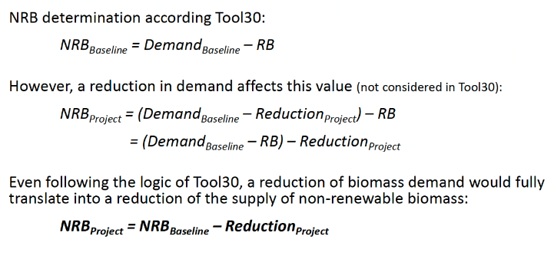
Thus, when consequently applying the logic of the HH level methodologies, fNRB can not be applied in the same way it is currently done, as it is not a constant factor through baseline and project scenario that is only applied to the households regarded in a project area.

One solution would be to revise the methodologies that use fNRB to adapt the landscape/forestry approach like MoFuSS attempts to and then applying the MoFuSS values for determining the carbon footprint of a project intervention on an area. But mixing the landscape approach of MoFuSS with the household level approach of the current methodologies used by projects applying Tool 30/33 where the project boundary is only the affected household and not all households in an area is conceptually incorrect and does not lead to any reasonable results for determining the project’s climate impact.

Understanding this error is crucial as it has a huge impact on a lot of projects. We thus plead the MP to put adequate resources into understanding and addressing this conceptual mistake before proceeding with any further recommendations that will only further solidify the erroneous concept.
We clearly see the MP and EB to be in the responsibility to commission relevant research and not only leave it to “Stakeholders to develop and propose new methodological approaches for calculation of fNRB values that result in further advancements in terms of accuracy and conservativeness, for consideration the CDM EB.” as currently suggested.

 | 5.5 16 |  | ge | “Stakeholders may also propose new methodological approaches for calculation of fNRB values that result in further advancements in terms of accuracy and conservativeness, for consideration the CDM EB.”.  We welcome this statement, but request to make the process for what these new methodological approaches need to fulfil to be considered as a sufficient model much clearer. Where do the responsibilities for the development lay?  Is a general suggestion of concept enough to be considered? Or does it need to be a fully worked out model?  Does it need to be a scientifically peer-reviewed model? What are the requirements? What is the role of DNA approving values?  Is there a plan to allow MoFuSS results that go beyond MoFuSS-derived regional and national values? What are the criteria to apply these values? If so, what are the criteria for the input values? | Include a lot more information and details on the requirements and planned process for proposing new methodological approaches.
 | 5.5 Table 3 |  | ge | Please provide explanation why only values on a national level are proposed when in theory MoFuSS has the ability to provide values on a much higher spatial resolution | Include explanation and reasoning for only regarding fNRB on a national level when it is known to have very high spatial variance in some regions.
1 | Information Note: Development of default fNRB values | Point 39 | te | The currently suggested text removes the Monte Carlo-derived standard deviations of the model output that is achieved by a parametrization approach of some of the model parameters. However, including the best available uncertainty assessment of a model output is essential and basic scientific practice. Thus, this value needs to be included as it shows the important fact that, while it is currently the best possible available model, the fNRB values calculated by MoFuSS still contain a high model uncertainty, which is not a criticism of the model but a plain reflection of the quality of the best available data in this field. Removing this model standard deviation and replacing it with the standard error of the spatial mean across the model in certain regions is scientifically meaningless and implies a false, exaggerated certainty that no model in this field likely can ever achieve. | Replace the spatial mean with the model standard deviation as in previous versions.

