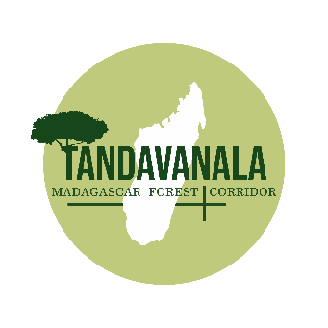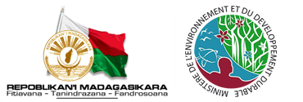

**DESIGNATED NATIONAL AUTHORITY CLEAN DEVELOPMENT MECHANISM**

**NGO TANDAVANALA**

*Madagascar Forest Corridor*

**DISCUSSION PAPER**

**Determining Madagascar’s**

**default fNRB value**

NOVEMBER 2023

This discussion paper has been prepared by the technical team of the Malagasy NGO

ONG Tandavanala and resources from Madagascar’s Designated National Authority

which sits within the Ministry of Environment of Madagascar

**Table of Contents**

1. Introduction 3

1.1 Background 3

1.2 Purpose 3

2. Madagascar Country Update 5

2.1 Country Overview 5

2.2 Local Malagasy Experience 6

2.3 Malagasy Landscape 7

3. Technical Advice 8

3.1 Country-level default fNRB values 8

3.2 Reducing Madagascar’s default fNRB value 8

3.3 Interrogating the proposed 22% default fNRB value 8

3.3.1 Calculating a new fNRB value 9

3.3.2 Calculating non-renewable biomass (NRB) 9

3.3.3 Calculating total annual biomass removals (R) 10

3.3.4 Calculating demonstrably renewable biomass (DRB) 10

3.4 Calculating an accurate fNRB value 11

4. Next Steps 12

# Introduction

## Background

Over recent months, clean cookstove methodologies used for voluntary carbon market projects certified by the UNFCCC Clean Development Mechanism (CDM), Verra and Gold Standard, have faced over-crediting concerns, including from some academic research that has found cookstove emission reductions were up to 6.2 times over-credited.

In response, the UNFCCC and the non-profit Clean Cooking Alliance (CCA) have been working to find better approaches to make cookstove methodologies more consistent. This has included the review and proposed update of ‘fraction of non-renewable biomass’ (fNRB) country-level default values – a key factor used to assess the number of carbon credits that can be generated from a cookstove carbon project.

|  |
| --- |
| The fNRB value effectively measures the rate of deforestation in an area or jurisdiction. More specifically it measures the relative amount of wood that is harvested beyond the landscape’s natural capability to regenerate.  When deforestation occurs:   * at a slower rate than forests are able to naturally regenerate (fNRB below 50%), then the harvesting of trees, limbs, and other wood is considered sustainable. * at a faster rate than forests are able to naturally regenerate (fNRB above 50%), then the harvesting of trees, limbs, and other wood is not considered sustainable.   Locations with higher fNRB values have the potential for greater emissions reductions from cookstove carbon projects, as deforestation is occurring faster than forests are able to regenerate.  Applying a higher fNRB value supports a stronger baseline case for the emission reduced from the implementation of energy efficient cookstoves that reduce consumption of wood derived from these forests. |

Research recently undertaken by the Stockholm Environment Institute (SEI) and the Autonomous University of Mexico (UNAM), and released for consultation by the CDM Executive Board, seeks to recalculate the existing national fNRB default values. The UNFCCC intends to use these updated values to help address current over-crediting concerns.

Through consultation however, concerns have been raised that these recalculated values:

* apply blanket rates for regions rather than specific rates for individual countries, including for Central America (31%), South Asia (28%) and South-East Asia (40%);
* use global satellite imagery and wood supply model data, rather than accurate local data; and
* are using these incorrect assumptions and data inputs for 42 Sub-Saharan African countries, including Madagascar’s 22% fNRB value (proposed below global average 30% fNRB value).

The CDM Executive Board is due to consider consultation responses at its next meeting in November 2023. If these updated default values are approved, they will likely be quickly adopted by global carbon standards (e.g., Verra and Gold Standard) and applied to new projects. This will also impact existing projects that use previously established higher fNRB values.

## Purpose

The purpose of this discussion paper is to:

1. provide a deeper analysis of the environmental, economic and social pressures facing Madagascar, and how they contribute to legitimately higher fNRB values used by cookstove carbon projects in the country; and
2. dispute the extremely low Madagascar default fNRB value of 22% proposed by the CDM Executive Board.

This paper includes technical, statistical and anecdotal information, and sets out next steps for consideration of higher fNRB values that are reflective of Madagascar’s current on-ground reality.

# Madagascar Country Update

## Country Overview

Madagascar is the world’s fifth largest island (approx. 59 million hectares), and is increasingly facing climate impacts, including declining rainfall, and more frequent extreme weather events such as droughts and cyclones[1]. Officially classified as a Least Developed Country (LDC), 75% of Madagascar's 28 million people live in poverty[2], with many rural communities dependent on subsistence-level agriculture and local forest ecosystems for their livelihoods.

Madagascar is generally thought of as a densely forested nation, and although it is a megadiverse landscape hosting 5% of the world’s flora and fauna species (with 80% indigenous to Madagascar)[3], the on-ground reality is very different.

Over the last two decades, rampant deforestation, a rapidly increasing population and expanding climate impacts, have reduced Madagascar's tree cover by 27%, leaving many households dependent on local forests for firewood without access to their traditional energy resource; forcing them instead to spend approximately 30% of their household income on purchasing wood for cooking on open fires.

**Figure 1: Madagascar Tree Cover Loss 2001 – 2022**

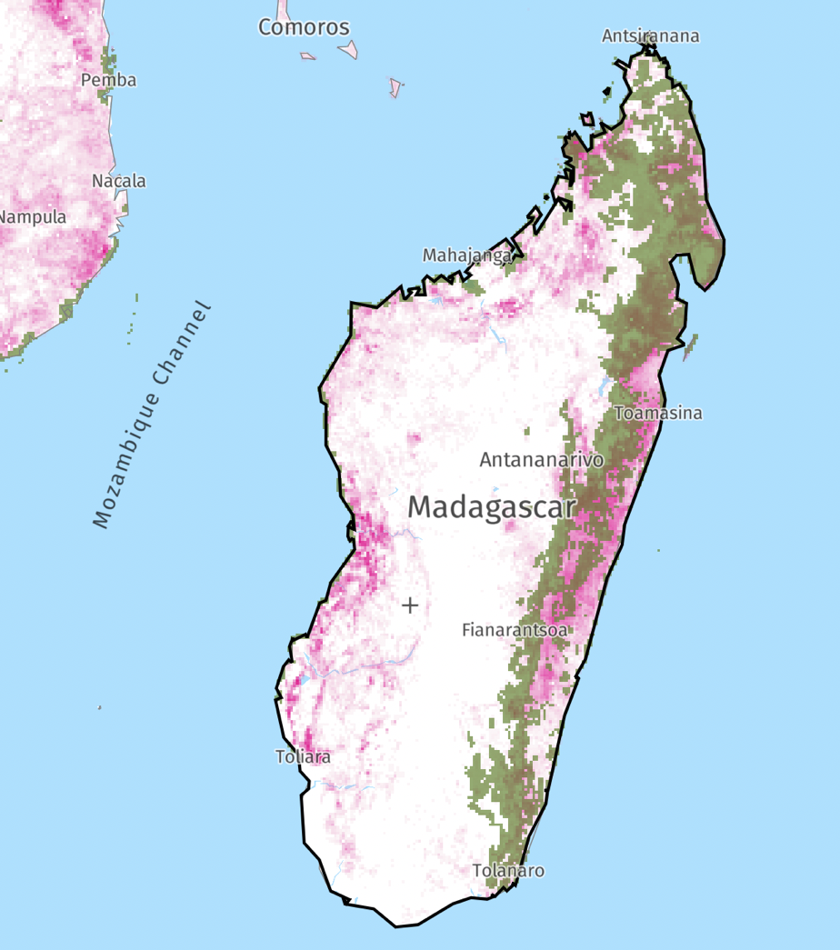Over the last few centuries Madagascar has lost 80% of its natural forest cover and continues to lose an average of 200,000 hectares of forest annually[4] to deforestation from illegal logging of precious woods, production of charcoal, slash-and-burn agriculture, and firewood collection.

In the last two decades (2001-2022), Madagascar lost 4.62 million hectares (27%) of its remaining forest cover, equivalent to 2.29 billion tonnes of greenhouse gas emissions released into the atmosphere[5].

In 2022 alone, Madagascar lost 256,000 hectares of forest cover, equivalent to 135 million tonnes of greenhouse gas emissions[6]. If deforestation remains at current levels all of Madagascar’s forests could be lost within the next 25 years.

Figure 1 (right) shows the tree cover loss over the last two decades, and the remaining primary forests along the easter regions of the island[7].

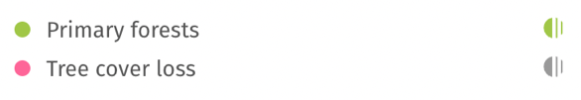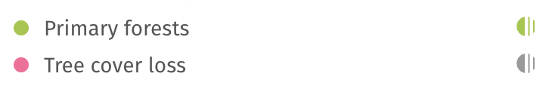

## Local Malagasy Experience

Unlike in other countries on mainland Africa, communities across Madagascar do not have access to cleaner fuel alternatives, and so a large proportion of wood collected from forests is used for cooking. With rapid population growth in the last few decades, much of the landscape has been cleared for agriculture, and so access to intact forest areas near population centres has become increasingly difficult. The increasing distance to forest resources has forced the majority of rural and regional households to purchase firewood, and this financial impact pushes communities further into poverty.

Community dependency on local forest ecosystems is different from many other sub-Saharan countries, and as the forest biomass is used at a much faster rate than the forest can naturally replenish, deforestation and forest degradation has become widespread. The resulting loss of topsoil erosion, desertification and loss of biodiversity has exacerbated already high levels of poverty and food insecurity, and has also contributed to more severe environmental impacts from extreme weather events.

|  |
| --- |
| **In an interview in April 2023, about the impact of cookstove projects in the region, Mr Herisoa Jocelin Richard Ramammonjisoa, Mayor of Kelilalina Commune (Ifanadiana District, Vatvavy Region) provided the following comments about the deforestation impacts:**  “*In developing countries you can see clearly the amount of environmental destruction over the last 20 years. Here in this region people still practice slash and burn agriculture. This has led to deforestation which has contributed to climate change and as a result we have less and less water.”*  *“Our harvests have declined as a result of this environmental destruction of the forest. In developing countries like Madagascar climate change has an especially big effect on local communities as 90 percent of the people are farmers who rely on growing their own crops.*”  “*The destruction of the environment and the overuse of the land to grow crops has reduced the levels of harvest. The population in Madagascar is growing very quickly especially in rural areas. Some families have five to six children each, other families can have even more with as many as ten to twelve children. As the population increases then the land becomes more infertile which causes great problems for the local community.*”  “*Deforestation has had a big impact on the community living here as now they have to spend a long time searching further afield for firewood in order to cook their food.*” |

Further consultation with communities involved in cookstove projects and those more connected to deforestation issues have reported anecdotally that:

* there are no birds in the skies anymore, because the forests have disappeared.
* the landscape around villages are completely different from what they were 20 years ago.
* communities and local government groups are actively trying to conserve remaining forest areas and look for ways to regrow deforested land.
* Following cyclone and storm events, hills around villages are experiencing landslides, as removal of forest areas has increased soil erosion issues across the landscape.

## Malagasy Landscape

Aerial and landscape images have also been provided below to give a better sense of the landscape. Whilst some trees and remnant vegetation remains, the majority of the landscape has been cleared for firewood collection and charcoal production, and to make way for fields around villages kept for rice and bean crops, fruit trees and grazing space for small herds of livestock.

This reinforces the situation experienced on the ground that whilst there are still intact forest areas in the country, they are typically far from population centres, and so it is highly likely that the local fNRB values (deforestation rate) in areas where cookstove carbon projects would be undertaken, would be significantly higher than those values taken at a national level – although for Madagascar this still should be high to reflect the dire situation facing the country.

**Figure 2: Images of the Malagasy Landscape**

|  |  |
| --- | --- |
| *Villages surrounded by land cleared for rice fields.*  ***Haute Matsiatra Region*** | *A mother cooks with firewood on a traditional open fire.*  ***Vatovavy Region*** |
| *A man chops wood to sell in Communes (half day walk)*  ***Haute Matsiatra Region*** | *Forests felled for firewood sales in the region.*  ***Haute Matsiatra Region*** |
| *A woman brings home firewood purchased at the market.*  ***Vatovavy Region*** | *Families use less firewood to cook with a cookstove.*  ***Vatovavy Region*** |

# Technical Advice

At a high level, country-level default fNRB values can be a useful data input into cookstove carbon project calculations, particularly where subnational data is used to inform the country-level calculation and fNRB values. The proposed fNRB values for Madagascar do not appear to accurately reflect the on-ground impact of deforestation in the country, and so two main issues have been raised below for consideration by the CDM Executive Board in its deliberations.

## Country-level default fNRB values are not necessarily the most accurate measure of deforestation as forest distribution is not uniform across all regions within a country. Localised values should be used to determine accurate fNRB values for the unevenly forested nation of Madagascar.

Madagascar has lost 27% of its national forest cover in the last two decades, and as the drivers of deforestation are predominantly human-induced, they are occurring closer to population areas – which are spread unevenly across the country. A country-level ‘weighted average’ fNRB value does not accurately reflect this variance of deforestation across regions; it is likely that the actual rate of deforestation in a project area will deviate from this mean fNRB value, and so where possible subnational data should be used to ensure fNRB values can be as accurate as possible.

The 72% fNRB value for Madagascar, determined in 2012 was based on national-level data, and so when compared with subnational-level data it appears inaccurate. Similarly, the 22% fNRB value proposed for Madagascar is based on country-level data, and sits well below the global average fNRB value of 30%. Subnational data has not been available for use in determining this value and so it does not accurately reflect real rates of deforestation across the country.

Large cookstove carbon projects in Madagascar have used subnational fNRB values based on data gathered in real-time by independent scientific research institutions. An example of this regional data used is set out in the Figure 3, below.

These baseline and fNRB studies were undertaken across five regions and accurately reflect the local deforestation rates of carbon project areas. This data has been taken in the last five years, and has been reviewed and approved by the Madagascar Designated National Authority (DNA) for baseline use.

More detailed data can be made available upon request to help ensure that country-level fNRB values more accurately reflect the reality of deforestation on the ground in Madagascar.

## Reducing Madagascar’s default fNRB value from 72% to 22% implies deforestation has significantly reversed in the last 10 years, which is not reflective of the on-ground reality.

As outlined in section 1.1 of this paper, an fNRB value below 50% shows that deforestation is decreasing, and that forest harvest/usage is being done sustainably (i.e., forest regenerating faster than it is being harvested). Using the appropriate fNRB calculation tool, a value of 22% assumes that:

* 78% of current forest harvest is being done sustainably;
* The remaining unsustainable wood fuel harvest/use) has peaked and is rapidly declining; and
* in the last decade the annual growth rate of Malagasy forests has increased by more than three times the growth rate measured in 2012.

An average country-level fNRB value of 22% would require a deforestation rate of 0% in the majority of regions across Madagascar. It would also require that the rate of deforestation in Madagascar is less than the global average of 30%. Subnational data gathered in independent studies (noted above), reflect much higher rates of deforestation across the country, and so it is our belief that the proposed 22% fNRB value for Madagascar cannot practically represent the in-country reality.

## Interrogating the proposed 22% default fNRB value using the Annex 20, EB 35 calculation tool supports the positions set out in section 3.1 and 3.2.

The equations and tools used to calculate default fNRB values are set out in the UNFCCC CDM SSG-35 Working Group [Information note on Default values of fNRB for LDCs and SIDs](https://cdm.unfccc.int/Panels/ssc_wg/meetings/035/ssc_035_an20.pdf), specifically those listed in Annex 20, EB 35 of the document.

The proofs below seek to explain the settings that would be required in each circumstance for calculations to support a 22% ‘significantly reduced’ hypothesis – and why such a calculation would not be practically possible in country given local data and experience available.

These proofs compare a reduced 2023 deforestation rate to that measured in 2012.

### Calculating a new fNRB value

The main equation referred to in Annex 20, EB 35, is that:

|  |  |
| --- | --- |
| *fNRB =* | *NRB* |
| *NRB + DRB* |

Where:

|  |  |
| --- | --- |
| *fNRB* | Fraction of non-renewable biomass (fraction or %) |
| *NRB* | Non-renewable biomass (t/yr) |
| *DRB* | Demonstrably renewable biomass (t/yr) |

Under this equation, *fNRB* will only decrease if:

* *DRB* increases; or
* *NRB* decreases.

|  |
| --- |
| For the deforestation rate (*fNRB*) to be lower now than it was in 2012, either forests would have to be regenerating faster (*DRB*), and/or would need to be harvested slower (*NRB*) than it was 10 years ago. |

### Calculating non-renewable biomass (*NRB*)

Annex 20, EB 35 also notes that:

‘a national-level default value for *fNRB* can be derived by calculating Total annual biomass removals (*R*) from each country and estimating the proportion of *R* that is demonstrably renewable (*DRB*) and non-renewable (*NRB*).’

|  |
| --- |
| *NRB = R – DRB* |

Where:

|  |  |
| --- | --- |
| *NRB* | Non-renewable biomass (t/yr) |
| *R* | Total annual biomass removals (t/yr) |
| *DRB* | Demonstrably renewable biomass (t/yr) |

Under this equation, *NRB* will only decrease if*R* is a lower value than*DRB***.**

|  |
| --- |
| For the volume of wood used in traditional cooking (*NRB*) to be lower now than it was in 2012, the total forest wood harvested would need to be lower than the volume of forest wood regenerated 10 years ago. |

### Calculating total annual biomass removals (R)

Annex 20, EB 35 also notes that:

|  |
| --- |
| *R = MAI + ΔF* |

Where:

|  |  |
| --- | --- |
| *R* | Total annual biomass removals (t/yr) |
| *MAI* | Mean Annual Increment of biomass growth (t/yr) |
| *ΔF* | Annual change in living forest biomass (t/yr) |

Under this equation, *R* will only decrease if both *MAI* and *ΔF* decrease.

|  |
| --- |
| For the total forest wood harvested (*R*) to be lower now than it was in 2012, both the annual average forest growth rate (*MAI*) and the annual change in living forest biomass (*ΔF*) would need to be higher than 10 years ago. These would need to have been improved through significant human intervention, and in Madagascar there are no known initiatives of policies implemented since 2012 that would drive such material improvements in these values.  Furthermore, in these regions where projects have been undertaken, subnational data shows that the change in living forest biomass (*ΔF*) has been indirectly reduced due to the success of cookstove carbon projects that have significantly reduced the volume of wood being burned for cooking. |

### Calculating demonstrably renewable biomass (DRB)

Annex 20, EB 35 also notes that:

|  |
| --- |
| *DRB = PA* x *GR* |

Where:

|  |  |
| --- | --- |
| *DRB* | Demonstrably renewable biomass (t/yr) |
| *PA* | Protected Area Extent of Forest (ha) |
| *GR* | Annual Growth Rate (t/ha-yr) |

Under this equation, *DRB* will only increase if *PA* and *GR* increases.

|  |
| --- |
| For the volume of regenerated forest (*DRB*) to be higher now than it was in 2012, both the protected forest area (*PA*) and the annual forest growth rate (*GR*) would need to be higher than they were 10 years ago. These would need to have been improved through significant human intervention, and in Madagascar there are no known initiatives of policies implemented since 2012 that would drive such material improvements in these values, particularly in the country’s protected forest estate (*PA*).  Furthermore, there are no significant improvement in indicators (e.g., rainfall, soil carbon improvement) that would materially improve natural forest growth rates (*GR*). |

## Calculating an accurate fNRB value

While deriving the 2012 country-level default fNRB values, many international data inputs were included, including from the Intergovernmental Panel on Climate Change (IPCC), and the UN Food and Agriculture Organisation (FAO). Whilst these are likely to be high quality data inputs, they are taken at a global level and may not be representative of any once country’s actual circumstances.

The input values considered during 2012 for Madagascar's default value was as follows:

|  |  |  |  |  |  |  |  |  |  |
| --- | --- | --- | --- | --- | --- | --- | --- | --- | --- |
|  | ***F*** | ***GR*** | ***MAI*** | *Δ****F*** | ***R*** | ***PA*** | ***DRB*** | ***NRB*** | ***fNRB*** |
|  | Extent of Forest (ha) | Growth Rate of biomass (t/ha-yr) | Mean Annual Increment (t/yr) | Annual Change in Living Forest Biomass (t/yr) | Total Annual Biomass Removals (t/yr) | Protected Areas Extent of Forest (ha) | Biomass Growth in Protected Areas (t/yr) | Total Annual Removals – Protected Area Growth | Fraction of non-renewable Biomass |
| **MADAGASCAR** | **12,553,000** | **3.26** | **40,922,780** | **(14,000,000)** | **54,922,780** | **4,752,000** | **15,491,520** | **39,431,260** | **72%** |

Taking into account subnational data and direct observation of on-ground realities, a significant reduction in rate of deforestation (decline of forest cover) has not taken place in the last 10 years. As detailed in section 2, it is likely that the opposite has occurred, in that Madagascar has lost 4.62 million hectares (27%) of its existing forest cover[8]. It is reasonable to assert therefore, that 22% is not a reliable default fNRB value, nor is it representative of what is happening on-ground in Madagascar.

Calculation of the proposed 22% requires a clear understanding of all data used and should assess these inputs against the practical realities of the on-ground Malagasy context – particularly noting the possible impact of global datasets on the accuracy of a final fNRB value for Madagascar.

# Next Steps

Whilst there are areas of the country with intact forests, the majority of these are far away from population centres. As a result, there are likely to be significant variation of the fNRB values at a subnational level. If accurate, scientific on-ground data can be provided, we believe that the fNRB values will be higher than the proposed national default value of 22%.

Some existing cookstove carbon projects undertaken in Madagascar have derived localised subnational fNRB values with technical work and surveys undertaken by independent scientific and technical research institutions. These studies are available for comparative analysis that might assist in confirming more relevant data inputs to build more accurate country-level values.

**We welcome the opportunity to engage and provide this data through the proper channels, upon request.**

1. [UNEP Ecosystem-based Adaptation Madagascar 2014-2020](https://www.unep.org/resources/factsheet/ecosystem-based-adaptation-madagascar-2014-2020)
2. [World Bank Madagascar Country Overview](https://www.worldbank.org/en/country/madagascar/overview#:~:text=The%20situation%20is%20exacerbated%20by,using%20the%20national%20poverty%20line)
3. [Science.org Madagascar's Extraordinary Biodiversity: Threats & Opportunities](https://www.science.org/doi/10.1126/science.adf1466)
4. [Global Ecology & Conservation Status of Deforestation in Madagascar (April 2023)](https://www.sciencedirect.com/science/article/pii/S2351989423000240)
5. [Global Forest Watch Madagascar Country Summary](https://www.globalforestwatch.org/dashboards/country/MDG/?location=WyJjb3VudHJ5IiwiTURHIl0%3D)
6. [Global Forest Watch Madagascar Country Summary](https://www.globalforestwatch.org/dashboards/country/MDG/?location=WyJjb3VudHJ5IiwiTURHIl0%3D)
7. [Global Forest Watch Madagascar Country Summary](https://www.globalforestwatch.org/dashboards/country/MDG/?location=WyJjb3VudHJ5IiwiTURHIl0%3D)
8. [Global Forest Watch Madagascar Country Summary](https://www.globalforestwatch.org/dashboards/country/MDG/?location=WyJjb3VudHJ5IiwiTURHIl0%3D)