TABLE FOR COMMENTS
Name of submitter: Nuno Barbosa
Affiliated organization of the submitter (if any): UniCarbo
Contact email of submitter: nuno@unicarbo.com.br

0 | 1 | 2 | 3 | 4 | 5 | 6
# | Para No./  Annex / Figure / Table | Line Number | Type of comment  ge = general  te = technical ed = editorial | Comment  (including justification for change) | Proposed change  (including proposed text) | Assessment of comment  (to be completed by UNFCCC secretariat)
1 | 28 | 4 | te | Based on data obtained from a specific CDM project activity, we created a Base Scenario that represents typically expected results of a determination of the biannual measurement of the flare efficiency in a high temperature enclosed flare for biogas that is normally used in LFG destruction initiatives implemented in landfill sites.  By making an analytical analysis of the influence of quantitative variations in the results of performed measurements for the parameter to be monitored ex-post “𝐹𝐶𝐻4,𝐸𝐺,𝑡“ in the results of the calculation of 𝜂𝑓𝑙𝑎𝑟𝑒,𝑐𝑎𝑙𝑐,𝑦, one will conclude that an improbable dramatically high measurement deviation for “𝐹𝐶𝐻4,𝐸𝐺,𝑡“ would marginally impact the result of the calculated value for 𝜂𝑓𝑙𝑎𝑟𝑒,𝑐𝑎𝑙𝑐,𝑦. For example: a dramatic increase of 900% on the measured values for 𝐹𝐶𝐻4,𝐸𝐺,𝑡 would typically result in a reduction of only 0,018% of determined value for 𝜂𝑓𝑙𝑎𝑟𝑒,𝑐𝑎𝑙𝑐,𝑦. On the other hand, a dramatic reduction of 99% in the value of “𝐹𝐶𝐻4,𝐸𝐺,𝑡“ would typically result in increase of only 0,002% in the value of 𝜂𝑓𝑙𝑎𝑟𝑒,𝑐𝑎𝑙𝑐,𝑦. Thus. It is our opinion that adding an uncertainty factor of 5% in the equation for the determination of 𝜂𝑓𝑙𝑎𝑟𝑒,𝑐𝑎𝑙𝑐,𝑦 would represent an unjustifiable direct reduction in achieved emission reductions by combustion of LFG in high temperature enclosed flares of 5%. Such reduction would per se direct represent 5% in reduction of associated revenues due to commercialization of CERs generated by a typical CDM initiative promoting flare of LFG.  The results of the performed analysis of the typical variation of the parameters and the changes in the result of the flare efficiency is summarized below:  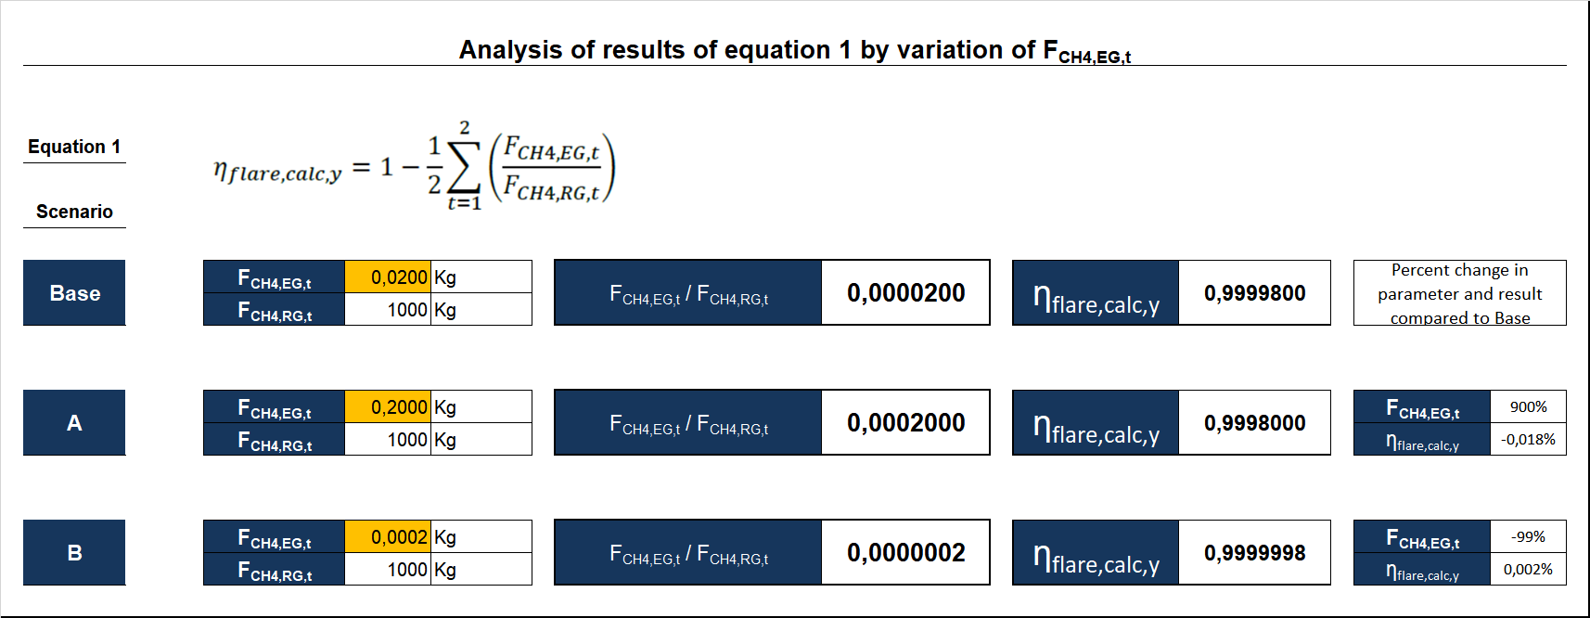 | The calculated flare efficiency η_{flare,calc,m} is determined as the average of two measurements of the flare efficiency made in year y (η_{flare,calc,y}), as follows:  