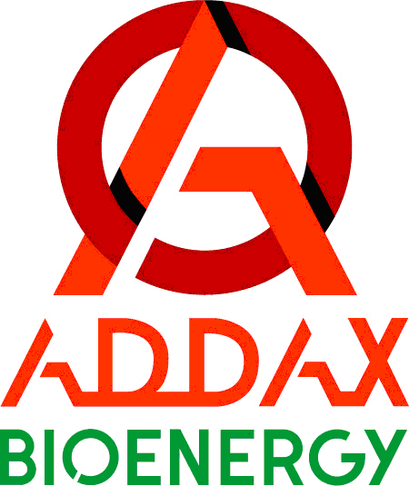

Dear Meth Panel members,

Following your call for public inputs on the draft "Consolidated methodology for electricity and heat generation from biomass residues" which may replace existing ACM0006 methodology, please accept enclosed contribution of Addax Bioenergy Sierra Leone Ltd.

Addax Bioenergy, created in 2007 with the objective to develop renewable energy sources in Africa, is currently developing an integrated agricultural and renewable energy plant in the Northern Province of Sierra Leone. A high-efficiency biomass-residues fired cogeneration plant would be included under a CDM project, given the contribution to the reduction of carbon emissions that will be achieved by the export of clean electric power generated from residual sugarcane biomass to the national grid of Sierra Leone. This project will be the 1st CDM activity in this Least Developed Country where no other CDM project has ever been considered at all.

We have been informed that the applicable methodology ACM0006 was undergoing potential replacement by this new draft open for public inputs. Although the new draft seems to valuably simplify and clarify the assessment of the baseline scenario for heat, power and biomass use and the demonstration of additionality by integrating all the guidelines which were previously referred to in separate tools, we are concerned about the fate of Least Developed Countries provisions. Indeed, since our ongoing project takes place in Sierra Leone, a LDC with serious shortfalls in administrative, economic and technical procedures, we intended to rely on the specific Guideline 7 for objective demonstration and assessment of barriers from EB50 Annex13, which alleviates the stringency of the actual demonstration of barrier compared to other countries with easier business environment.

Now that all previously referred tools are directly integrated in this draft new methodology, we would like to make sure the provisions of Guideline 7 for LDCs will still be available and applicable in proving the eligibility of projects in LDCs and not prevented by the exclusive use of the new draft methodology which does not incentive to refer to separate baseline and additionality tools and guidelines anymore. Therefore, we would suggest the inclusion of a specific mention or footnote regarding LDCs (or at least the possibility of referring to additional guidelines) in the barrier analysis section of the draft methodology ACM00XX.

Thank you for your understanding and efforts.
Kind regards,

Pierre-Olivier Buisson
Addax Bioenergy Management SA Manager,
For and on behalf of Addax Bioenergy Sierra Leone Ltd

