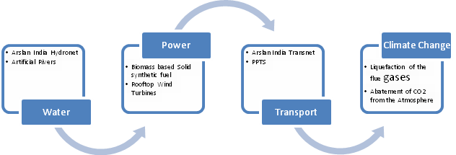
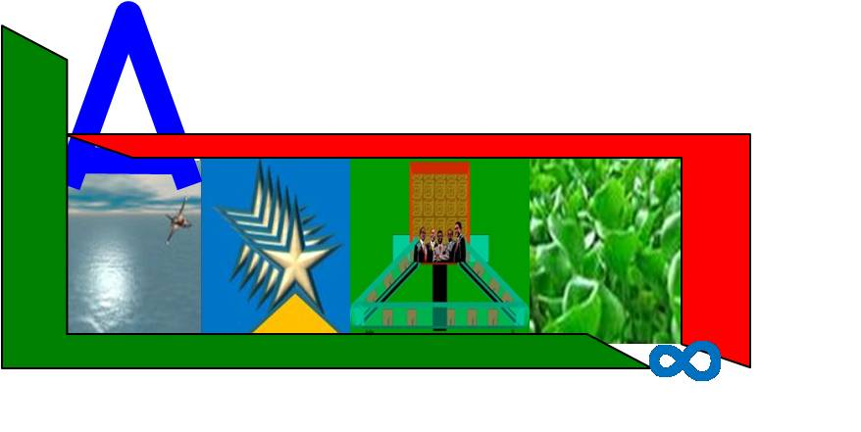

ARSLAN
SCIENTIFIC, PHYSICAL & INDUSTRIAL RESEARCH
EMPOWERING PLANET EARTH & HUMANKIND
( a private, voluntary, Trust dedicated to R & D since 1972 in collaboration with AMM Limited at Bangalore, Mumbai, Nagpur & Delhi, India)

Call for inputs on efficiency in the operation of CDM & opportunities for improvement
This is a good call. I pray that the heavens bless you for your efforts.
We have designed a project that can take out all the estimated 30 billion Tons of GHG in India alone or the same can be implemented in different countries to the extent they emit the gases. The Timeline for the purpose depends on the Funds available. A commitment of US $150 billions per year would be sufficient to start but at least a firm commitment of a Trillion US Dollars is essential, which can then be raised and the project implemented. By 2012 Insha’Allah, we would be taking out all the accumulations in the atmosphere and stop all future emissions.
I could follow the format of CDM Board to get approvals. I HAVE STUDIED THE DOCUMENTATION AND IT HAS TAKEN ME MORE THAN A YEAR TO UNDERSTAND THE DOCUMENTATION. The problem is there are number of new methodologies that first need to be approved which may take years. And then the Application may take yet another one or two years. This frightens investors and as well people who have developed the methodologies.
Could you simplify the procedures? To ease up the procedures, this is what I am suggesting. This is just loud thinking.
Based on the methodologies that could be explained by the Project Proponent to the Board or a Committee who could be constituted for the purpose, or the Agencies already existing, and the plausibility of Technologies involved, the Committee could approve in principle the project.. This would enable the PP to source funds and then start the project. And then the actual emission reductions could be obtained by a team that would monitor the process of reductions in the project established by the PP. And CER’s then could be traded. In the initial stages the project could be small, medium or very large. There should be no compunction about the scale. That an approved methodology should first be tried on a small scale has no meaning. This is because a small scale attempt would not succeed. The nature of the methodology is such. But an assurance or guarantee that a similar project would not be approved for different PP who may use the methodology or the derived methodologies which he may innovate once the basic idea is known is necessary. Otherwise there would be no incentive.
Or why should not the CDM Board buy an universal technology which can then be passed on to different countries for a royalty, who may by themselves use the technology to reduce and abate emissions. This will enrich the UN as whole and enable it to get enormous funds for accomplishing its objects, rather depend on recalcitrant Governments for funds.
Or why should not the CDM Board just outsource the job of emission reductions to some one like us.
Faiyaz Muhammed Pasha
Email: arslanindia@yahoo.com
Mobiles: +91-9899613304
+91-9268606659

