 |  | 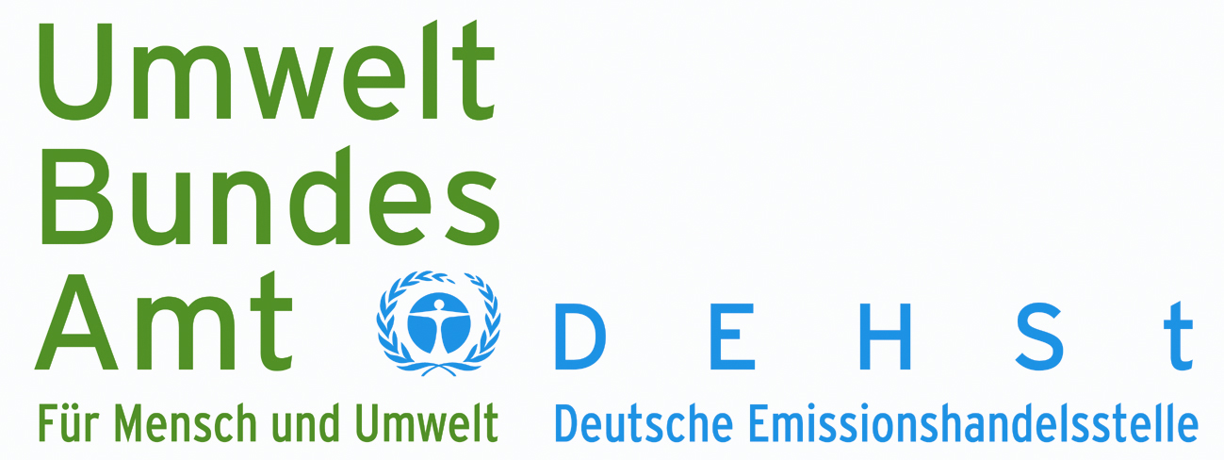
Umweltbundesamt | Deutsche Emissionshandelsstelle
Postfach 330022 | 14191 Berlin
Members of the CDM Executive Board  c/o UNFCCC Secretariat  P.O. Box 260124  53153 Bonn |  | Berlin, 30.08.2008  Telefon: (0 30) 89 03 – 50 50  Telefax: (0 30) 89 03 – 50 10  E-Mail: German.dna.dfp@uba.de

Programme of Activities
Input to the Public Call from 6 August to 3 September 2008

We welcome the opportunity to express our opinion concerning procedures and modalities for a Programme of Activities. Germany considers the programmatic approach as an important contribution to promote projects in categories like energy demand and especially energy efficiency for private households, where we see a large GHG-reduction potential that has not been tapped by the CDM so far. This is also true for other energy efficiency measures involving small sources as well as for transport projects. At the same time we perceive that programmatic projects can contribute significantly to sustainable development. For these reasons we consider it important not to burden this approach inappropriately with complicated monitoring and verification requirements. Transaction costs have to be aptly balanced with the methodological requirements necessary to meet the demand for environmental integrity.
Germany acts as host country for JI-projects to enable the private sector to discover possibilities to reduce GHG-emissions that are additional to measures and incentives provided by the government. In this context the Federal Environment Agency as Designated Focal Point has so far approved two programmatic projects and there are several projects in the pipeline, that we expect to endorse in the near future. We would like to share the experiences we have gained assessing these programmatic projects.
The two approved projects are “Pilot Programmatic Joint Implementation Project in North-Rhine-Westfalia (JIM.NRW)” and “RWE Climate Bonus Project Heat Pumps”. JIM.NRW supports energy efficiency measures in small and medium sized companies which are not covered by the Emission Trading Scheme of the European Union. The measures comprise modernization or preterm exchange of steam and central heating boilers with or without fuel switch. “RWE Climate Bonus Project Heat Pumps” gives private home owners an incentive to replace their heating system with an electric heat pump before the technical lifetime of the old boiler expires or they are obligated to replace it by law. For detailed information please refer to the following internet-address: www.dehst.de/JI-Projects-Germany
For both projects we accepted a barrier analysis to prove the additionality of the programme and did not require an investment analysis, as these were new programmes designed specifically for the purpose of creating JI-projects. In this early “pilot phase” for programmatic projects it seems reasonable to encourage entities to design and implement programmes as they are facing conceptual and institutional challenges. These “pioneers” have to shoulder additional transaction costs because of the novelty of the approach and we therefore consider a barrier analysis as sufficient to prove additionality of the programme.
To proof the additionality of each CDM programme activity we accepted an exemplary additionality test in the Project Design Document as well as an example of the data sheet participants will have to fill out. The collection of the relevant data for each CPA will then suffice as a proof of additionality. A separate proof of additionality for each single programme activity would require a disproportionate amount of effort and expenditure compared to the emission reductions generated by a single activity.
We therefore consider the provisions in paragraph 15 (b) on page 4f of the “Procedures for Registration of a Programme of Activities as a Single CDM Project Activity and Issuance of Certified Emissions Reductions for a Programme of Activities” as problematic. The liability of the validating DOE for erroneous inclusion has created significant insecurity in the market and has proven to be a barrier for the development of PoAs.
Another item that creates a disadvantage for programmatic CDM compared to other projects are the provisions in Section F on page 6 of the above mentioned document. The “Implications of an approved methodology being put on hold or withdrawn” generate added insecurity for the implementation of PoAs in an area that project participants cannot influence.
Last but not least, in the glossary of the CDM terms on page 28 it is determined that “The starting date of the CPA cannot be before the date of registration of the PoA.”. As the project developer cannot predict the exact date of registration with any certainty, this stipulation makes it nearly impossible to plan a Programme of Activities.
Regarding the combination of the three provisions described above, it is not surprising that so far project developers have shirked to apply the programmatic approach for inherently programmatic projects. Instead they have circumvented the requirements by reducing the number of CPAs so that they were able to apply small scale methodologies. An example are four projects in India, currently at validation or requesting registration. They all comprise the distribution of compact fluorescent lamps in exchange for incandescent light bulbs and use methodology AMS II.C, although they are exactly the kind of projects the instrument of PoA was created for. Therefore we consider it indispensable to remove these provisions that put Programmes of Acitivities at a definite disadvantage.
Complex monitoring and verification requirements constitute another barrier that discourages project developers to consider Programmes of Activities. For the programmatic approach as well as for “conventional” CDM projects we consider it helpful to pursue methodologies that reduce the transaction costs and efforts of monitoring by using conservative statistical estimates as a baseline. These assumptions can be complemented by representative statistical samples of ongoing Project Activities. The size of the samples needs to remain within manageable proportions so that transaction costs do not reach prohibitive heights. This stipulation is proven by methodology AM0046 “Distribution of efficient light bulbs to households” which includes extremely complex monitoring provisions. This resulted in the project developer using AMS II.C instead. By using a small scale methodology the scale of targeted households and emission reductions achieved by the project is obviously smaller and does not have the effect Programmes of Activities are expected to deliver.
The following provisions in paragraph 7 on page 2 of “Guidance on the registration of project activities under a programme of activities as a single CDM project activity” (Annex 38 to the minutes of the 32nd Meeting of the Executive Board) represent another barrier for the effective implementation of programmatic CDM: “All CPAs of a PoA shall apply the same approved baseline and monitoring methodology, involving one type of technology or set of interrelated measures in the same type of facility/installation/land.” Especially in the area of energy efficiency it makes sense to combine several measures so that each project participant can reach the utmost level of efficiency according to his individual circumstances. This approach was applied in the programmatic JI project “JIM.NRW”, where project participants can either replace or modernize a steam or central heating boiler and this can also be complemented by a fuel switch. No CDM-Methodology was available to monitor the resulting emission reductions. Generally it would be more efficient for Programmes of Activities if a combination of suitable methodologies could be used, as the development of a new methodology represents a major barrier for project developers.
We hope our input contributes to advance the procedures and modalities for Programmes of Activities with the result that programmatic approaches are more widely used. This would contribute to our common goal to tap unused potentials for climate mitigation on a large scale with measures that significantly promote sustainable development at the same time.

