Part 1- Clinker. Kiln design and process 3
1.1 Clinker production process description 5
Part 2- Combustion, Flame and Heat Balance. 23
2.1 Combustion 23
2.1.1 Solid fuels 24
2.1.2 Liquids 30
2.1.3 Gases 31
2.1.4 Alterns 31
2.2 Flame and burner 32
2.3 Heat Balance 39
Part 3- Kiln system operation and control 42
3.1 Kiln parts and their functions 42
3.1.1 Cyclones tower 42
3.1.2 Calcinator or fuels brun in the fumes chamber. 44
3.1.3 Kiln tube 48
3.1.4 Coolers 51
3.1.5 Production level 58
3.1.6 Operational Utilization 59
3.1.7 Electricity consumption 59
3.2 Control variables 60
3.2.1 What velocity is required for the kiln? 61
3.2.2 What flue level is needed in the kiln? 65
3.2.3 What fuel level is required? 67
3.2.4 What feed level is allowed? 68
3.3 Control parameters 69
3.3.1 Pair or spin moment (motor’s amperage) 70
3.3.2 NOx 71
3.3.3 O₂ and depressions 71
3.3.4 TV camera, zone temperature and hot stage temperature. 72
3.3.5 Analytics 72
3.3.6 Output gas temperature 73
3.3.7 Kiln’s vision 73
3.3.8 Weight/Liters 73
3.4 Control 73
Part 4- Kiln operation and control under special conditions 80
4.1 Kilns cooling, heating and start up. 80
4.1.1 Start up. Establishment level and system recovery. 86
4.1.2 Start up abacus and kiln recuparation 88
4.2 Kiln at low production 89
4.3 Process protection enclave 95
Part 5- Refractory and Kiln reparation protocol. 96
5.1. Refractory covering 96
5.1.1 Provisions 96
5.1.2 Types 96
5.1.3 Refractory brick 97
5.1.4 Bricks formtas 101
5.1.5 Layout systems for refractory brick 102
5.1.6 Refractory lifetime - compaign 104
5.1.7 Spots 105
5.2. Refractory concrete 107
5.2.1 Refractory concrete drying 109
5.3. Refractory specifications 110
5.3.1 Chemical request – chemical decline 111
5.3.2 Thermal request – thermal decline 114
5.3.3 Mechanical request – mechanical decline 116
5.3.4 Kiln tube corrosion 119
5.4. Kilns ovality and alignment 122
5.4.1Kilns alignment 123
5.5. Prolongated shut down of a facility (more than 2 months) 124
5.6. General repairs protocol 125
5.7 Refractories consumption and campaigns duration 131
Part 6- Emissions. 133
Annex A Part I. Bogue Potential composition approach 143
Annex B Part I. FRS and DRX equipment calibration 154
Annex A Part II. Combustion 160
Annex B Part II. Heat Balance 164
Annex C Part II. Flame calculations 167
Annex D Part II. System temperatures calculation 169
Annex E Part II. Thermal conductivity and insulation 170

Part 1- Clinker. Kiln design and proces

The fundamental objective of this chapter is to expose in a simple and operative manner, all those basic concepts to design clinker and operate kilns satisfactorily.
With respect to clinker design, it cannot be disconnected from cement design nor the availability and characteristics of the raw materials, but quite the opposite, as it will be seen ahead, from the nature of the raw materials it will come off a range of possible crude/clinker designs, that proven in the cement design will give rise to a clinker production as optimal for the quality of the cement to commercialize and the global cost of the plant. The calculation tools that are going to be described are thought, like in the rest of the chapters, to be simple, of minimum data and easy to obtain, and throwing results that allow to plan and/or to diagnose. For that reason they use approaches that cannot be seen from an inoperative “Purism”, as well as of empirically obtained nonbibliographical equations that try to fill dangerous emptinesses.
Kiln Balance Tool
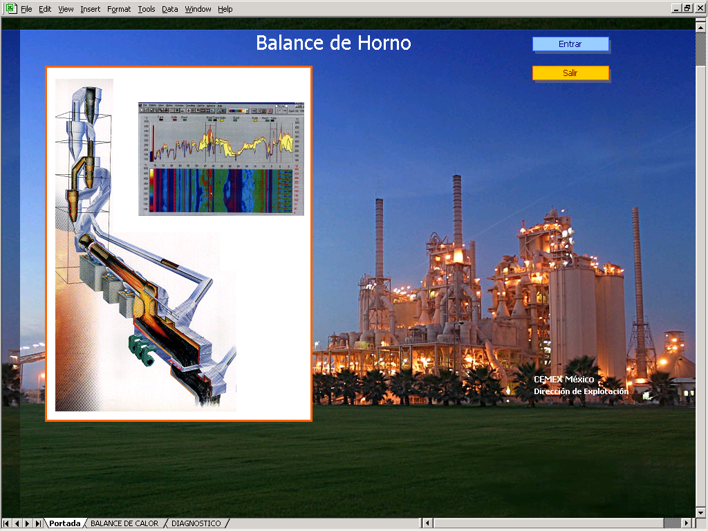
General Repairs Tool
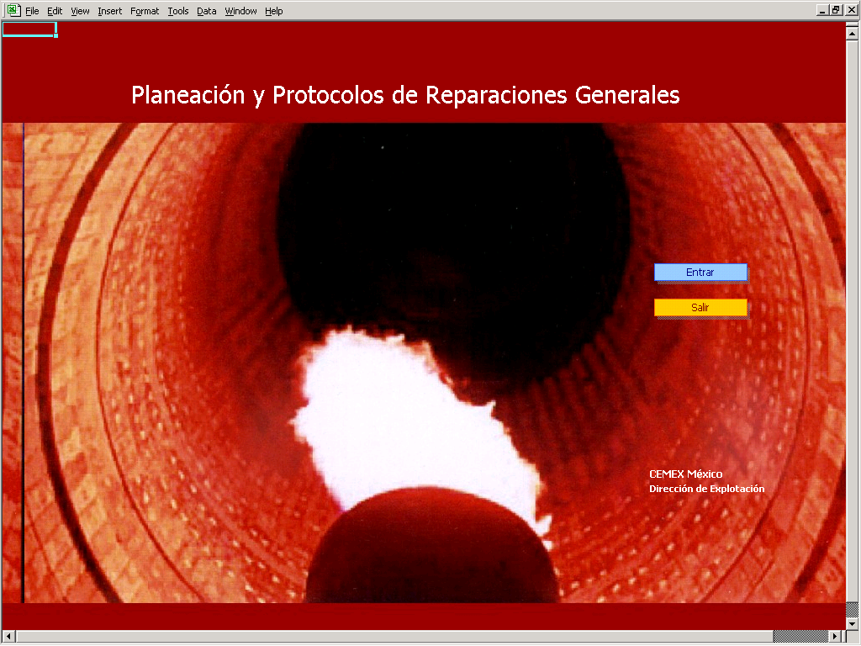

1.1 Clinker production process description
The diagram exhibits the main processes involved in producing clinker in a dry process kiln.
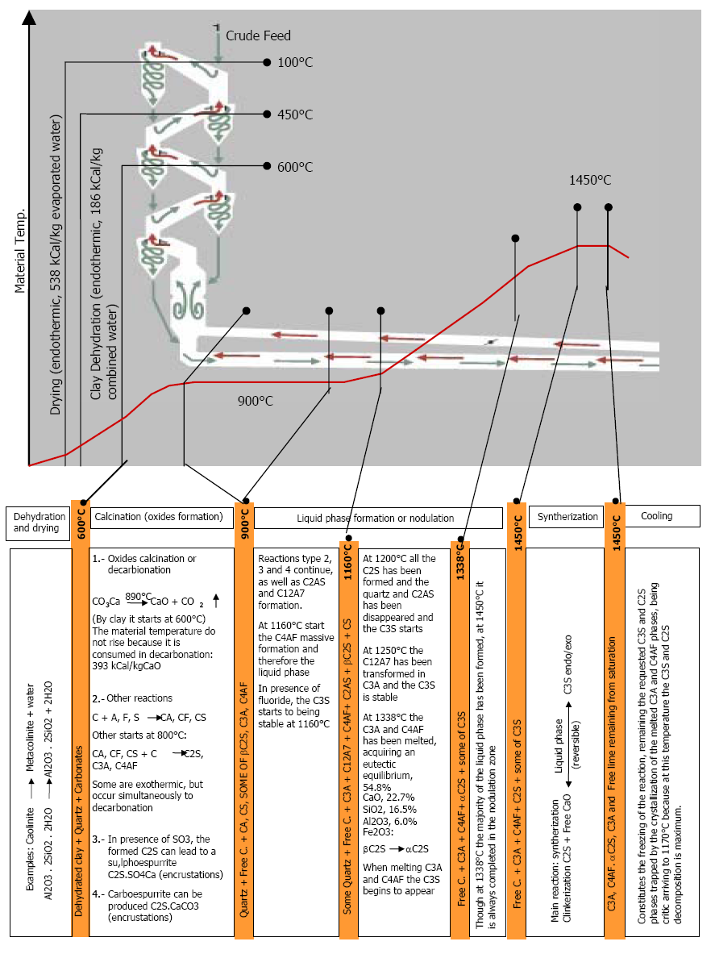
All the phases formation processes happened in the kiln are solid-solid reactions (outlined in the previous figure) that will depend on the diffusion speeds. Fastest in spreading is the calcium, which does in the form of Ca2+, soon follows aluminum and iron, in forms Al³⁺, Fe3⁺ and, finally, the silicon, that does in the form of SiO₄²⁻. Without iron or aluminum, solid-solid reaction C₂S +CaO_{L} to give C₃S takes place over 2000°C. Given the relation between the molecular weights of the CaO and SiO₂, it is established that the optimal lime, corresponding to the saturation without leftover or lacking for the C₃S generation, is:
3 Pm CaO VS 1 Pm SiO2 and therefore:
Optimal CaO = [ 3.Pm CaO / 1.Pm SiO₂ ] . SiO₂ = 2.8 SiO₂

The aluminum presence favors the solids diffusion in it, lowering the temperature, which occurs over 1470°C, being the relation for the optimal lime:
Optimal CaO = 2.8 SiO₂ + 1.18 Al₂O₃

Finally, the iron incorporation returns to reduce the clínkerización temperature around 1450°C, being the optimal relation between the elements of:
Optimal CaO = 2.8 SiO₂ + 1.18 Al₂O₃ ₊ 0.65 Fe₂O₃

Values 1.18 and 0.65 are empirical values to not being the pure phases that are formulated in Bogue (see Annex A, p.129)

In this way a relation between the real total lime level and the optimal one is established, denominated “saturation degree” that expresses how saturated is the lime respect to the rest of elements.
LSF (Lime Saturation Factor) = 100 * CaO / Optimal CaO.
LSF = 100 * CaO / (2.8 SiO₂ + 1.18 Al₂O₃ ₊ 0.65 Fe₂O₃)

Whichever greater LSF level is looked for, more energy will be required by greater amount of carbonates to descarbonate, unless the CaO comes from other minerals different from carbonates.

The inclusion of other elements modifies this module of Lea& Parker; thus:
- The magnesium presence elevates this degree when getting up itself (until a maximum of 2%) or replacing calcium in the crystalline networks, forming analogous compounds to the C₃S, C₂S, etc (M₃S, M₂S…)
- On the other hand, the calcic sulfate presence in clinker reduces lime for the clínkerization reactions, reason why it has to be considered in its stoichiometric relation CaO/SO₃.

In this way, the LSF is corrected to the expression:
LSF = 100 * [ CaO* + 0.75 MgO* - 0.7 SO_{3 excess} ] / [ 2.8 SiO₂ + 1.18 Al₂O₃ ₊ 0.65 Fe₂O₃ ]
* Note: Only until 2% of MgO, since the rest is not incorporated to the clinker phases. If it is discounted the free lime generated to the total CaO, the operative LSF is obtained, the one that “the kiln enjoyed”. The SO3 in excess with respect to alkalis.
This relation between the common element in all the phases, the CaO, and the rest, cannot characterize a crude or clínker by itself, being necessary more information regarding the easiness (temperature) for being combined. Thus other two modules arise:
Silicic or Silica module (MS): is the relation between solids and liquids that will favor their diffusion, and that therefore will reduce the clinkerization temperature.
$\text{MS}=\frac{\text{Solids}}{\text{Liquids}}=\frac{C_{3}S+C_{2}S}{C_{3}A+C_{4}\text{AF}}=\frac{{\text{SiO}}_{2}}{{\text{Al}}_{2}O_{3}+{\text{Fe}}_{2}O_{3}}$

It is then an indirect measurement of the liquid phase percentage that will be seen more ahead.
- MS inferior to 2.0: they generate excessive scab thickness, firing easiness and liquid phase excess.
- MS superior to 3.0: they generate little scab thickness, little liquid phase and high thermal load to achieve firing.
Therefore the MS is very related to the kiln temperature to which the clinkerization will occur.

Aluminic or melt module (MA): is the relation between main melting materials, the alumina that melts at high temperatures and the iron that does at low temperatures.
MA = Al₂O₃ / Fe₂O₃
Therefore the MA is very related to the kiln portion where the liquid phase percentage specified by the MSwill be obtained
- MA superior to 2.3: the liquid phase begins too late (towards the kiln material unloading), the F.L will be viscous.
- MA inferior to 1.3: the liquid phase begins too soon (towards the kiln material entrance), the F.L will be fluid.

Summarizing the concepts of the modules that characterize a crude/clinker and the operation in its chemical part (already will see mineralogy and sorting), it is obtained that:
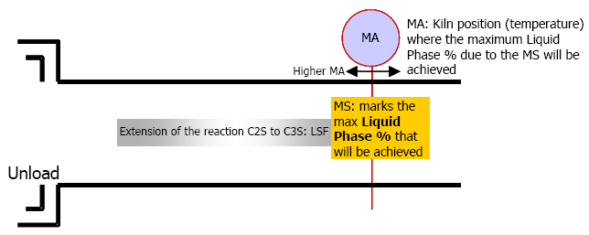

Part 3- Kiln system operation and control

The objective of this section is to show the concepts and calculations for a kiln control as well as a uprooted recovery of the same after a start up.

3.1 Kiln parts and their functions
Before entering into matter, first it has to be considered on a given installation, the “Bottle Necks” and for it first describe what it is being requested to each part.

3.1.2 Calcinator or fuels brun in the fumes chamber.

a) Calcinator
The existence or not of a calcinador and its disposition determine the tower denomination, see page page 47.

3.1.3 Kiln tube
Facing design mainly and to evaluate our installation as a pure kiln tube, the following formulas appear:

$$\begin{aligned}\text{CT}=\text{thermal load }=({\text{Gcal}}/{{\text{hm}}^{2}})≃0\text{.}\text{23}⋅{\text{Tpd}}^{0\text{.}2}⋅(\text{\%}\text{ppal}\text{.})^{0\text{.}\text{34}} \\ \text{where}:\text{\%ppal }=\text{percentage of calories in the main burner} \\ \text{ CT }=\text{ Design estimated thermal load } \\ \\ \text{Tpd}=\text{production level}≃\frac{\text{10}\text{.}\text{28}⋅D_{i^{3\text{.}\text{84}}}}{0\text{.}\text{06}⋅(\text{\%}\text{ppal})^{0\text{.}\text{72}}} (\text{for white multiply by 0}\text{.}\text{65}) \\ \\ \text{where: }D_{i}=\text{ Ferrule internal diameter} \\ \\ \text{CR}=\text{total refractory consumption }(\text{gr/ton})=\text{Brick}+\text{Concrete}=\text{17}\text{.}5⋅{\text{CT}}^{2\text{.}2}+\text{100} \\ \\ \text{DC}=\text{ campaign normal duration }(\text{months})=\text{770}⋅{\text{CT}}^{−2\text{.}\text{64}} \\ \\ \text{Note}1:\text{ the usual relation Longitude/Diameter }({\text{L/D}}_{i})\text{ is of 14 to 17 for kilns } \\ \text{with preheater without calcinator and of 10 to 15 with calcinator}\end{aligned}$$

