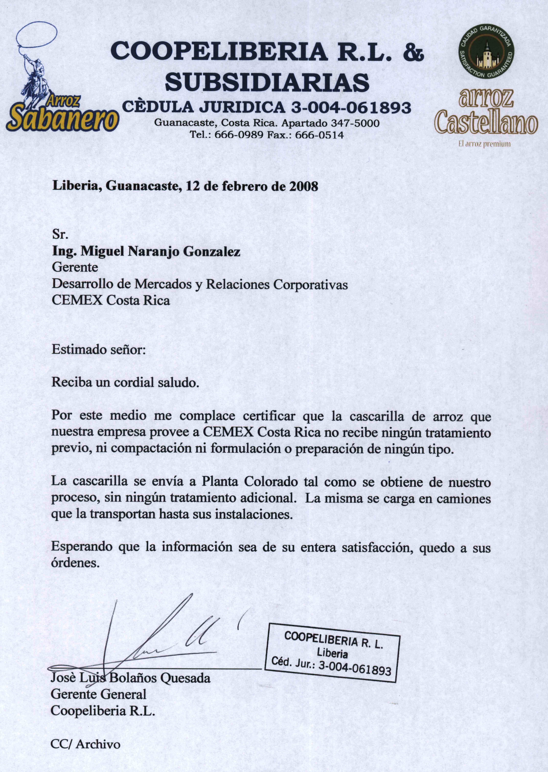
Textual translation

Liberia, Guanacaste, February 12, 2008

Mr.
Miguel Angel Naranjo Gonzalez
Manager
Market Development and Corporatives Relations
CEMEX Costa Rica

Dear Sir,

Receive a Best Regard.

By this means it pleases to me to certify that the rice husk that our company provides to CEMEX Costa Rica does not receive any previous treatment, neither compaction nor formulation or preparation of any type.

The husk is sent to Colorado Plant as is obtained from our process, without any additional treatment. The same is loaded in trucks that transport it until yours facilities. Hoping that the information is of their whole satisfaction, I am at you order.

Jose Luis Bolaños Quesada
General Manager
Coopeliberia R. L.

Cc/Archive
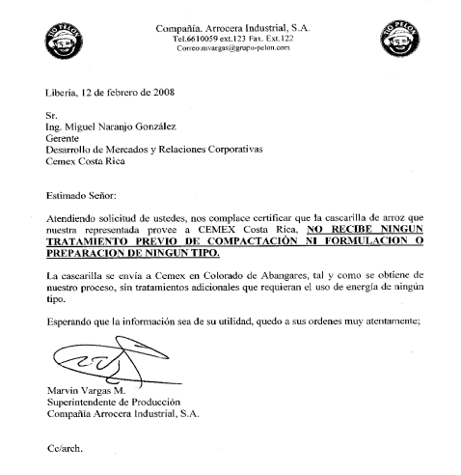
Textual Translation

Liberia, February 12, 2008

Mr.
Miguel Angel Naranjo Gonzalez
Manager
Market Development and Corporatives Relations
CEMEX Costa Rica

Dear Sir:

Taking care of your request, it pleases to us to certify so that the rice husk that represented ours provides to CEMEX Costa Rica, DOES NOT RECEIVE ANY PREVIOUS TREATMENT OF COMPACTION NOR FORMULATION Or PREPARATION OF ANY TYPE, the husk is sent to Cemex in Colorado de Abangares, and as it is obtained from our process, without additional treatments that require the use of energy of no type.

Hoping that the information is of their utility, I am his you order very kindly;

Marvin Vargas M.
Production Superintendent
Compañia Arrocera Industrial, S. A.

Cc/archive.

