CLEAN DEVELOPMENT MECHANISM
PROJECT DESIGN DOCUMENT FORM (CDM-SSC-PDD)
Version 03 - in effect as of: 22 December 2006

CONTENTS

A. General description of the small scale project activity

B. Application of a baseline and monitoring methodology

C. Duration of the project activity / crediting period

D. Environmental impacts

E. Stakeholders’ comments

Annexes

Annex 1: Contact information on participants in the proposed small scale project activity

Annex 2: Information regarding public funding

Annex 3: Baseline information

Annex 4: Monitoring Information

Revision history of this document

Version Number | Date | Description and reason of revision
01 | 21 January 2003 | Initial adoption
02 | 8 July 2005 | - The Board agreed to revise the CDM SSC PDD to reflect guidance and clarifications provided by the Board since version 01 of this document.  - As a consequence, the guidelines for completing CDM SSC PDD have been revised accordingly to version 2. The latest version can be found at <http://cdm.unfccc.int/Reference/Documents>.
03 | 22 December 2006 | - The Board agreed to revise the CDM project design document for small-scale activities (CDM-SSC-PDD), taking into account CDM-PDD and CDM-NM.

SECTION A. General description of small-scale project activity

A.1 Title of the small-scale project activity:
>>
Biomass based Hot Air Generation at Fertilizer Unit of Tata Chemicals Ltd., Haldia, West Bengal

Version: 5

Dated: 15th January 2008

A.2. Description of the small-scale project activity:
>>
Purpose of the project activity:

The objective of the project is to reduce greenhouse gases emissions to the extent possible from the fertilizer manufacturing process by replacing fossil fuel with biomass fuel.

The Haldia Unit of Tata Chemicals Limited is into the fertilizer and chemicals manufacturing business. The project proponent requires hot air for the purpose of evaporating the moisture content in the final product (fertilizer and STPP) to the desired level. As a current practise the unit fires furnace oil (FO) in the Hot Air Generator (HAG) to generate hot air. There are four HAG systems dedicated to the three plants viz. DAP1, DAP2, and STPP respectively. Due to increasing cost of FO, the project proponent decided to switch the fuel to a cheaper alternative. The natural choice was coal, as good quality of coal is abundantly available in the region at a cheaper rate and thus assures good return on investment. Tata Chemicals Limited (TCL) has decided to switch to the cheaper option and therefore decided to procure and install a Hot Air Generator which can be run by a solid fuel. However, keeping in view the global concern on climate change, Tata Chemicals also decided to check the availability of any renewable and climate neutral fuel that would avoid green house gas emissions. Based on above decision, the next choice was rice husk – discarded biomass residue produced by rice mills during production of rice. Rice husk has moderate calorific value to be utilized as industrial fuel. However, to be able to utilize rice husk, the unit had to overcome several barriers. The objective of climate change mitigation and CDM incentive were the main driver for the project initiation. This initiative has been taken at time when TCL Haldia is still a low profit making company and is yet to generate the desired level of profits as targeted by TCL management during takeover in 2004.

TCL expects rice husk availability for 10 months in a year, thus, emissions reduction will occur to the extent of rice husk usage only. During unavailability of rice husk coal will be utilized. Project may fire coal along with rice husk. Thus, as discussed above, usage of 100% coal to generate hot air has been considered as baseline scenario.

The project Hot Air Generator (HAG) systems would utilize rice husk (biomass), partly or fully, as fuel instead of using coal as fuel which was a natural choice for switching over the fuel from furnace oil. Thus the project would contribute significantly towards the reduction of the anthropogenic emissions of anthropogenic greenhouse gas (GHGs) by source.
There are four HAG units have been considered under the project boundary. Out of the four HAG unit, one each unit belongs to DAP 1 and DAP 2 and rest two units contributed to the STPP unit. In the first year, only one unit, that is, HAG 1 which is linked with DAP1 unit will operate and from the next year onwards all the four units would be operating.

The view of the project participants of the contribution of the project activity to sustainable development:

The project contributes to Sustainable Development of the region inline with host country guideline, in the region of operation:

Environmental well being:

As the project utilizes the rice husk discarded by the rice mills as waste, thus helps in reducing the burden of agricultural waste in the region that is often left to decompose at the fields. It also reduces off-site GHG emissions such as methane from biomass decay in anaerobic condition at the rice fields. Further, it has been planned that the bottom ash generated from the units would be consumed as filler in DAP plant that would help in reducing the disposal problems.

Utilization of rice husk (biomass residue from the rice mills) will not only reduce GHG emissions by displacing fossil fuel (coal) but also help in controlling indiscriminate open air burning and of the residues in fields or decomposition under anaerobic condition. Open air burning of biomass may lead to N2O emissions and decomposition at fields may lead to methane emissions, both potent greenhouse gases. In addition biomass decomposition can cause obnoxious odour problems. Further, projects of this kind could marginally provide solutions to the problem of space constraint for the disposal and decomposition of agro residues, a common agricultural waste management problem in all agriculture based nations including in India.

Utilization of rice husk (biomass residue from the rice mills) will not only reduce GHG emissions by displacing fossil fuel (coal) but also help in controlling indiscriminate open air burning and of the residues in fields or decomposition under anaerobic condition. Open air burning of biomass may lead to N2O emissions and decomposition at fields may lead to methane emissions, both potent greenhouse gases. In addition biomass decomposition can cause obnoxious odour problems. Further, projects of this kind could marginally provide solutions to the problem of space constraint for the disposal and decomposition of agro residues, a common agricultural waste management problem in all agriculture based nations including India.

Technological well being:

The project has relies on indigenously manufactured Hot Air Generator equipments being procured from several vendor thus providing business to other sector. Such an initiative would boost indigenous technology development. The use of biomass for generating Hot Air in the chemical sector is a first of its kind.

Social well being:

The unit is located in the Durgachak area of Haldia in West Bengal and is expected to recruit two technicians to handle the HAG on permanent basis. Thus providing employment opportunities for the local people. Moreover, since the biomass would be collected from 200 km radius of Tata chemicals unit, therefore local employment option would be generated in order to handle and transporting the biomass.

Economic well being:

If registered as a CDM project, this initiative would encourage other industrial units in the region to take initiatives in order to reduce their non-renewable fuel consumption and natural resource wastage. Since Tata Chemicals unit is a non-profit making unit, as of now, the revenue generated from the CDM would help the unit to sustain the continued use of biomass for HAG.

A.3. Project participants:
>>

Name of Party involved (*) ((host) indicates a host Party) | Private and/or public entity(ies)  project participants (*) (as applicable) | Kindly indicate if the Party involved wishes to be considered as project participant (Yes/No)
Government of India | Haldia Unit, Tata Chemicals Limited | No

TCL Haldia unit will be the sole owner of the CERs generated from the project. The TCL Haldia unit shall be the principal contact for the CDM project activity. The contact information of project participant has been provided in Annex 1.

Many other entities from Annex I countries may join as project participants. The list of such participants will be provided before the project is submitted for registration.

A.4. Technical description of the small-scale project activity:

A.4.1. Location of the small-scale project activity:
>>

A.4.1.1. Host Party(ies):
>>
India
A.4.1.2. Region/State/Province etc.:
>>
West Bengal.
A.4.1.3. City/Town/Community etc:
>>
Haldia
A.4.1.4. Details of physical location, including information allowing the unique identification of this small-scale project activity :
>>
Location: All measures have been implemented or conceived within the manufacturing complex of Fertilizer Manufacturing Division of TCL located at Haldia, district East Midnapore, West Bengal, India. The approximate location of the unit is at 22° 1' 31''N latitude and 88° 3' 30''E longitude. The site is connected to the Haldia Port and about 90 km away from Kolkata Port and is well connected by rail and road. Durgachak is the nearest railway station from the site.

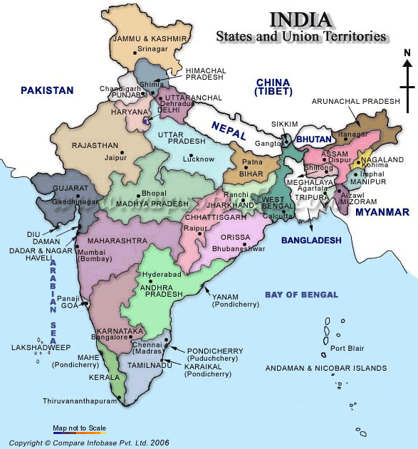

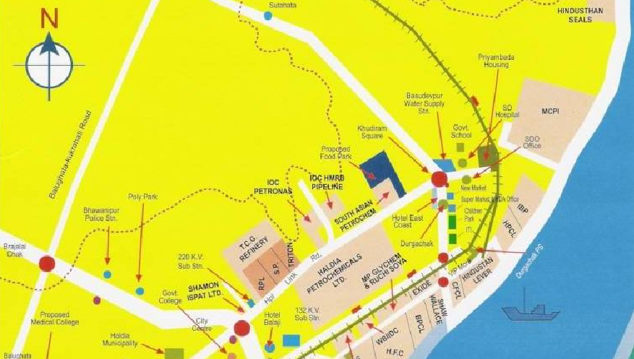

A.4.2. Type and category(ies) and technology/measure of the small-scale project activity:
>>

According to the categorization of Appendix B to the simplified modalities and procedures for small scale CDM project activities, the proposed Biomass based Hot Air Generation project activity can be appropriately categorised as Type AMS-I.C./ Version 12, Scope: 1, EB 33, “Thermal energy for the user”.

Reference: Appendix B of the simplified modalities and procedures for small-scale CDM project activities,
http://cdm.unfccc.int/methodologies/SSCmethodologies/approved.html

Justification to applicability of the selected project category AMS I-C:

The applicability criteria of the above mentioned small scale CDM project category are:

Technology/measure –

- Applicability Condition:
This category comprises renewable energy technologies that supply individual households or users with thermal energy that displaces fossil fuels. Examples include solar thermal water heaters and dryers, solar cookers, energy derived from renewable biomass for water heating, space heating, or drying, and other technologies that provide thermal energy that displaces fossil fuel. Biomass-based co-generating systems that produce heat and electricity for use on-site are included in this category.

Response:
The biomass based Hot Air Generation system encompasses renewable energy technology and includes utilization of rice husk as fuel (partial) for generating hot air (thermal energy). The unit proposed to install four HAG units connected to three different plants namely DAP1, DAP2and STPP which would utilize the biomass for generating hot air and would supply the same to the respective plants. The biomass based HAG is in substitution of coal based HAG system, thus replacing fossil fuel.

- Applicability Condition:
Where thermal generation capacity is specified by the manufacturer, it shall be less than 45 MW..

Justification to the applicability condition:
Since, the system is a co-fired system, this criteria is not applicable

- Applicability Condition:
For co-fired systems the aggregate installed capacity (specified for fossil fuel use) of all systems affected by the project activity shall not exceed 45 MWth. Cogeneration projects that displace/ avoid fossil fuel consumption in the production of thermal energy (e.g. steam or process heat) and/or electricity shall use this methodology. The capacity of the project in this case shall be the thermal energy production capacity i.e. 45 MWth.
Justification to the applicability condition:
Since the system will run by biomass for 10 months and by coal for about 2 months, therefore, we can refer the system as a co-fired system. Based on the given specification for each HAG by the manufacturer, it can be summarized as follows:

RREDA Fluidized Bed Model | RF-3800
Output | 32,68,000 kcal/Hr.
Maximum Hot Air Temperature | 300 ⁰C

Output of single Hot Air Generator is 2349590 KCal/hr. Since, the project consists of 4 units of HAG to be installed in the three different plants
Therefore, the total energy output of the co-fired systems (HAGs) under this project activity is equal to 2.73*4 MW thermal or 10.92 MW thermal.
Hence, as per the methodology requirement, for co-fired the energy output of the co-fired system is 10.92 MW thermal (<45 MW thermal) and therefore qualify under this category.

- Applicability Condition:
In the case of project activities that involve the addition of renewable energy units at an existing renewable energy facility, the total capacity of the units added by the project should be lower than 45 MWth and should be physically distinct from the existing units.

Justification to the applicability condition:
This is not applicable

From the above discussion, it can be concluded that project meets all the applicability criteria set out under the selected approved small scale CDM methodology and hence the project category IC is applicable to the proposed CDM project.

Technology:

This indigenously designed direct HAG has been specially developed to utilize the rice husk. The Fluidized Bed Direct Hot Air Generator (HAG) system is capable of combusting several types of solid fuels such as coal, biomass, wood scraps and precipitates from wastewater treatment, at high efficiency. In addition the emission control system of toxic gases such as sulphur dioxide and oxides of nitrogen in this technology is easy to operate and efficient. The overall thermal efficiency is 95%.

The biomass has been loaded to the hopper with a suitable material handling system. The hoppers in the system have a capacity to store 3 hrs of biomass or agro waste with a particle size below 4 mm. Screw conveyor feeding the fuel to the furnace are driven by the motors. The set temperature on a proportional-integral-derivative controller (PID controller) gives feedback to the inverter on fuel feeding and continuously varies speed of screw feeder to maintain desired temperature at process point. The temperature is controlled within + 2⁰C.

Fuel conveyed by the screwed feeder is sprayed by Screw Feeder (SFD) fan air inside the furnace at desired position. SFD fan air is controlled by inverter and controls air volume and pressure. FD fan installed in the system gives fluidization cum combustion air to the fuel through specifically designed nozzle. Furnace having sand as bed material. The bed material remains under continuous fluidization and bed temperature maintained is about 800⁰C. Fuels fall on this hot bed and burns fully and instantly. The furnace temperature is also over 800⁰C. As final desired temperature is near about 100⁰C, and the furnace temperature is more than 800⁰C, hence fresh cold atmospheric air has been added from the top to get the desired hot air temperature. The whole masses flow through the settling chamber where particle size over 250 microns has been settled. The hot air is then finally pass through the cyclone and where the particle size over 20 micron get settled and literally fresh hot air has been supplied to the respective plants for drying up the products.
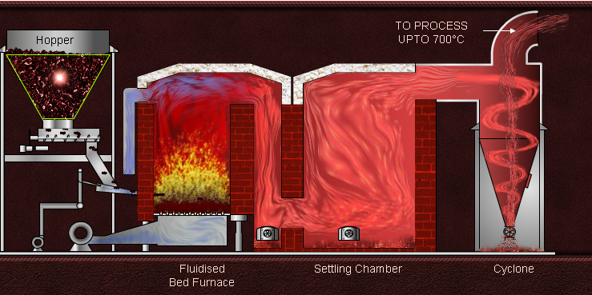
Direct Hot Air Generator

Fig: Direct Hot Air Generator
.

The implemented Hot Air Generator technology is sound and proves to be environmentally safe. The Hot Air Generator unit also contains Air pollution devices such as settling chamber, cyclone, rotary valves, gas duct line, control panel etc. Moreover, the project will utilize the bottom ash generated from the units as filler in DAP plants that would help in reducing the disposal problems.

A.4.3 Estimated amount of emission reductions over the chosen crediting period:
>>

The approximate emission reductions expected from the biomass base Hot Air Generation project are:

- 24261 tCO2e per year

- 242613 tCO2e over 10 years.

Following table shows annual generation of CERs in detail.

Year | Annual estimation of emission reductions in tones of tCO2e
1st Year | 6557
2nd Year | 26228
3rd Year | 26228
4th Year | 26228
5th Year | 26228
6th Year | 26228
7th Year | 26228
8th Year | 26228
9th Year | 26228
10th Year | 26228
Total estimated reductions (tonnes of CO2 e) | 242613
Total number of crediting years | 10 years
Annual average over the crediting period of estimated reductions (t of CO2 e) | 24261

A.4.4. Public funding of the small-scale project activity:
>>
No public funding has been sought for the project activity. The project proponent will identify potential participants if additional funds are required in the future.

A.4.5. Confirmation that the small-scale project activity is not a debundled component of a large scale project activity:
As mentioned under Appendix C of the Simplified Modalities and Procedures for Small-Scale CDM project Activities, the following results in debundling of a large CDM project:

“A proposed small-scale project activity shall be deemed to be a debundled component of a large project activity if there is a registered small-scale CDM project activity or an application to register another small-scale CDM project activity:
- With the same project participants;
- In the same project category and technology/measure; and
- Registered within the previous 2 years; and
- Whose project boundary is within 1 km of the project boundary of the proposed small-scale activity at the closest point”

The identified CDM project is being promoted by TCL Haldia Unit. The project proponent further confirms that it has not registered any small scale CDM activity or applied for registration another small scale CDM project activity within 1km of the respective project boundaries of these proposed projects, in the same project category and technology/measure. Hence the above criteria of debundling cases are not applicable for this CDM projects.

SECTION B. Application of a baseline and monitoring methodology

B.1. Title and reference of the approved baseline and monitoring methodology applied to the small-scale project activity:
>>
The baseline and monitoring methodology applied is the approved small scale methodology available for CDM project at UNFCCC website under CDM project activities.

Reference of selected methodology:
Approved Simplified Methodologies for SSC CDM project Activities AMS-I.C./ Version 12, Scope: 1,
EB 33

“Thermal Energy for the user”

B.2 Justification of the choice of the project category:
>>
Category I.C. “comprises renewable energy technologies that supply individual households or users with thermal energy that displaces fossil fuels” qualifies for project activity, a renewable energy technology which provides thermal energy (Hot air) and displaces fossil fuel usage.

Justification to applicability of the selected project category AMS I-C:

The applicability criteria of the above mentioned small scale CDM project category are:

Technology/measure –

- Applicability Condition:
This category comprises renewable energy technologies that supply individual households or users with thermal energy that displaces fossil fuels. Examples include solar thermal water heaters and dryers, solar cookers, energy derived from renewable biomass for water heating, space heating, or drying, and other technologies that provide thermal energy that displaces fossil fuel. Biomass-based co-generating systems that produce heat and electricity for use on-site are included in this category.

Response:
The biomass based Hot Air Generation system encompasses renewable energy technology and includes utilization of rice husk as fuel (partial) for generating hot air (thermal energy). The unit proposed to install four HAG units connected to three different plants namely DAP1, DAP2and STPP which would utilize the biomass for generating hot air and would supply the same to the respective plants. The biomass based HAG is in substitution of coal based HAG system, thus replacing fossil fuel.

- Applicability Condition:
Where thermal generation capacity is specified by the manufacturer, it shall be less than 45 MW..

Justification to the applicability condition:
Since, the system is a co-fired system, this criteria is not applicable

- Applicability Condition:
For co-fired systems the aggregate installed capacity (specified for fossil fuel use) of all systems affected by the project activity shall not exceed 45 MWth. Cogeneration projects that displace/ avoid fossil fuel consumption in the production of thermal energy (e.g. steam or process heat) and/or electricity shall use this methodology. The capacity of the project in this case shall be the thermal energy production capacity i.e. 45 MWth.

Justification to the applicability condition:
Since the system will run by biomass for 10 months and by coal for about 2 months, therefore, we can refer the system as a co-fired system. Based on the given specification for each HAG by the manufacturer, it can be summarized as follows:

RREDA Fluidized Bed Model | RF-3800
Output | 32,68,000 kcal/Hr.
Maximum Hot Air Temperature | 300 ⁰C

Output of single HAG is 32,68,000 kcal/hr. or 3.8 MW thermal
Since, the project consists of 4 units of HAG to be installed in the three different plants
Therefore, the total energy output of the co-fired systems (HAGs) under this project activity is equal to 3.8*4 MW thermal or 15.2 MW thermal.
Hence, as per the methodology requirement, for co-fired the energy output of the co-fired system is 15.2 MW thermal (<45 MW thermal) and therefore qualify under this category.

- Applicability Condition:
In the case of project activities that involve the addition of renewable energy units at an existing renewable energy facility, the total capacity of the units added by the project should be lower than 45 MWth and should be physically distinct from the existing units.

Justification to the applicability condition:
This is not applicable

From the above discussion, it can be concluded that project meets all the applicability criteria set out under the selected approved small scale CDM methodology and hence the project category IC is applicable to the proposed CDM project.

B.3. Description of the project boundary:
>>
Boundary – According to the selected approved project category the project boundary has been described as the physical, geographical site of the renewable energy generation delineates the project boundary. As recommended by the approved methodology, the physical location of the renewable energy generation has been considered as the project boundary.
For the present project the project boundary can be schematically presented as follows:

B.4. Description of baseline and its development:

>>
As per small scale methodology AMS.I.C applied as per paragraph 6 “baseline for renewable energy technologies that displace technologies using fossil fuels, the simplified baseline is the fuel consumption of the technologies that would have been used in the absence of the project activity times an emission coefficient for the fossil fuel displaced. IPCC default values for emission coefficients may be used” Project proponent has identified plausible project options for baseline scenario, which include all possible courses of actions that could be adopted in order to generate hot air. Further an assessment was conducted for each alternative to project activity with respect to the risks/barriers associated to implementation and their hot air generation costs, in order to arrive at the baseline scenario i.e. the most likely future scenario in absence of the project activity.

The performance of the project activity and its associated emission reductions were evaluated with respect to the baseline scenario.

The following possible alternative options have been reviewed:

Alternative 1: Coal based hot air generation

In absence of CDM project activity, TCL Haldia Unit could have generated hot air with coal as fuel to meet its requirement. This alternative is in compliance with all applicable legal and regulatory requirements and may be a part of the baseline. This is the cheaper option. When TCL has already decided to swich the fuel from F.O., coal was the option for which they also explored the feasibility.

Therefore the Alternative 1 is considered further for arriving at the baseline scenario.

Alternative 2: Natural gas based hot air generation

In absence of CDM project activity, project proponent could have generated hot air with Natural gas as fuel, to meet its requirement. This alternative is in compliance with all applicable legal and regulatory requirements. However this alternative would not be a credible and realistic alternative available with TCL in absence of project activity due to non-availability of natural gas as fuel for hot air generation to the plant.

Therefore the Alternative 2 may be excluded from further consideration.

Hence it has been concluded that in the absence of the project initiatives, TCL Haldia would have operated coal based HAG systems. Thus, the energy baseline is coal saved which would have been consumed in the absence of the project. Therefore the emission at the baseline is the emission that would have occurred due to combustion of fossil fuel required to consume at the baseline condition in the absence of the project. Accordingly, the emissions at the baseline have been calculated. 2005-2006 has been considered the base year for the present project.

Estimation of emission reductions resulting from the project activity

As guided in the applied methodology, the emission reductions resulting from the project activity is calculated as follows:
Emission reductions = Baseline emission – Project emission – Leakage emission

The Baseline emissions has been calculated based on the most appropriate baseline scenario which would have been coal, therefore in absence of project activity the hot air would be generated by coal.. The baseline emissions have been calculated based on amount of fossil fuel (coal) that would have been used in absence of the project activity. Average values based on Supplier’s data and supported by external test reports for Calorific values of coal has been used for baseline emission calculation. IPCC default value for emission co-efficient have been used to calculate the Baseline emissions. Please refer to Section B.6.1 for baseline estimation calculation.

The Project emissions and the leakage emissions would be zero as the project utilizes biomass residues that are renewable in nature. Please also refer to section B.6.1.

B.5. Description of how the anthropogenic emissions of GHG by sources are reduced below those that would have occurred in the absence of the registered small-scale CDM project activity:

As explained above, the project initiatives qualify under Type I.C.: “Thermal Energy for the User” of small scale CDM simplified modalities and procedure. The project additionality is analyzed below.

In accordance with paragraph 28 of the simplified modalities and procedures for small-scale CDM project activities, a simplified baseline and monitoring methodology listed in Appendix B may be used if project participants can demonstrate that the project activity would otherwise not be implemented due to the existence of one or more barrier(s) listed in attachment A of Appendix B. Similarly, for the identified CDM project, “Biomass based Hot Air Generation at Fertilizer unit of Tata Chemicals Ltd. at Haldia, West Bengal” following barriers have been overcome during project planning and execution:

Barrier Analysis

The following barriers, such as, Technological barrier, Financial barrier, barrier due to prevailing practice etc has been noticed.

Technological barrier:
- Inconsistency in quality and supply of Biomass: Energy generation projects that use biomass face barrier to entry: securing a long-term biomass source. Projects that do not have biomass residues associated with their operations as is the case with Tata chemicals are subject to price volatility in the biomass market as well consistent supply of biomass material.The biomass always carries a risk related to quality due to seasonal variation, moisture content variation and presence of impurities.
Although biomass is available in plentiful in the neighbouring districts but collection and supply of biomas material is not a organized sector in the state of West Bengal. The services of collection and supply of biomass material for industrial use is not practiced so ensuring consistent supply of biomass material is the biggest barrier to the project. Apart from the entity there are no other biomass users who use this material on a commercial scale and thus the services offered by the biomass suppliers is also the first of its kind for them. The suppliers are not sure of the amount that can be delivered and thus contracts are made only for a period of 1 year and will be reviewed at the end of the next year for further extension. This poses significant barrier with respect to ensuring consistent supply and future pricing that would come into effect once the contract is revisited and renewed on an annual basis. Moreover biomass contains a comparatively low calorific value than that of fossil fuel. Because of this quantum of biomass required equivalent to the fossil quantity is high. Consistent sourcing of biomass material including those in the lean season is a major hurdle for the project activity. Contracts executed with the biomass suppliers are on an annual basis only and this further poses huge uncertainty with respect to future supply. Other factors, such as price escalation, short supply, and space requirement are also different constrains.

- Clinker Formation: Due to low density of Biomass, the ash generated from biomass burning also has low density. This ash is known to have a tendency to adhere in the combustion chamber, thereby resulting in clinker formation. This may lead to plant shut down causing production losses. This also increases operation and maintenance.

- Storage space: Since the biomass is having a much lower density compared to coal, the requirement for storage volume is quite high; hence this would require a huge storage space. And the size of the Hopper for feeding the biomass into HAG needs to be modified.

- Handling of biomass: since biomass is much lighter as compared to coal and transportation of the same causes serious problem of blowing due to the low bulk density. The supplier had to be asked to specially pack the material in HDPE bags which is both time consuming as well costly in nature.

- Blocking of Primary Air Lines: During rainy season the biomass gets wet, it blocks the Primary Air lines at the time of feeding and thereby the plant efficiency and profitability may be affected.

- First of its kind technology in Fertilizer sector: This is unique in its application in this specific field. Since the quality of the chemicals is largely dependent on the consistent quality supply of Hot air and the biomass possesses several risk factors related to quality issues as described above, this is not a common case in fertilizer sector in India.

- Other barriers: Despite persistent efforts over the years, energy conservation culture among the industries has not spread to the desired level. Some of these barriers require fiscal and energy policy initiatives at both central and state government levels. Other activities require the strengthening and reinforcement of the organizational structure at central, state and district levels. There is a need to develop a strategy to build institutional capabilities, human resources and incentive systems to execute demand-side management programmes. Some of the barriers that have inhibited widespread energy conservation / fuel switch activities are given in the following table.

Source : Energy, environment and climate change issues : India , A study by the Asian Regional Research Programme in Energy, Environment and climate (ARRPEEC), http://www.arrpeec.ait.ac.th/Booklets/India_complete.pdf

In the project plant the barrier related to insufficient technical know how on usage of biomass material for heat generation, as the project is the first of its kind in the region, and inconsistency in the quality of the biomass material poses a formidable barrier to the project activity.

Financial barrier:

As per “appendix B of the simplified modalities and procedures for small scale CDM Project activities” financial barrier for the project is demonstrated when “a financially more viable alternative to the project activity would have led to higher emissions”.

The furnace oil prices in India were regulated through Administered Price Mechanism (APM) since the year 1998 but after that period this phenomenon was decontrolled and oil companies were entitled to decide the prices of fuel oil on the basis of import parity. In last few years, the price trend of the Furnace oil reflects the increasing trend and can be supported by the following facts and figures.:

Table: Wholesale Price Indices of Furnace Oil:

(1993-94 = 100)
Product | Weight (%) | 2000-01 | 2001-02 | 2002-03 | 2003-04 | 2004-05
Furnace Oil | 0.49335 | 203.5 | 179.7 | 227.2 | 265.5 | 347.4
All commodities | 100 | 155.7 | 166.8 | 175.9 | 187.3 | 195.6

It is evident from the above price trend of Furnace oil that this fuel is not a viable option as a fuel, especially for a non-profit making unit like Tata Chemicals Haldia unit. It has been mentioned in the TCL decision note that in light of the increasing trend in FO prices, TCL has thought of an alternate cheaper fuel like coal, which was also abundantly available in the region. However, keeping in view the global concerns on green house gas emissions, renewable fuels like biomass (rice husk) was proposed as alternate fuel for the HAGs.
The decision making process for the project was from switching from the baseline option of using coal in the hot air generators to using biomass material , which is not economical in nature. The unit cost of energy is used to demonstrate the economic attractiveness of the project and the baseline options i.e biomass as against coal to generate hot air.

For comparative analysis of the project activity vis a vis the baseline scenario unit cost of energy ( INR/Gcal ) is taken as the indicator. Table A provides the unit cost of energy for the project case and baseline scenario, which is generation of heat energy from coal fired system.

Table: A

 |  | FO |  |  | Coal |  |  | Biomass
Plant | section | Avg.CV (Kcal/l) | Qty, KL | Total Heat (Gcal/year) | Avg.CV (Kcal/kg) | Qty  (Tons) | CERs generated | Avg.CV (Kcal/kg) | Qty  (Tons/year)
DAP-1 |  | 9500 | 1,014.1 | 9,634 | 3527 | 2,876 | 4,745 | 2400 | 4,225
DAP-2 |  | 9500 | 1,652.8 | 15,702 | 3527 | 4,687 | 7,733 | 2400 | 6,887
STPP | SD HAG | 9500 | 3,514.4 | 33,387 | 3527 | 9,965 | 16,443 | 2400 | 14,643
STPP | Kiln HAG | 9500 | 1,653.9 | 15,712 | 3527 | 4,690 | 7,738 | 2400 | 6,891
Fuel Qty | MT |  | 7,835 | 74,435 | MT | 22,217 | 36,658 | MT | 32,647
Fuel Cost | Rs/MT |  | 20,300.00 | Gcal/yr | Rs/MT | 2,467.50 |  | Rs/MT | 3,500.00
Op.Cost | Rs.L /year |  | 1,590.55 |  | Rs.L /year | 548.21 |  | Rs.L /year | 1,142.64
Unit Cost | Rs/Gcal |  | 2,136.84 |  |  | 736.49 |  |  | 1,535.09

Basis of variables used In determination of unit cost of energy :
Calorific value of Coal: Average based on the analysis reports provided by the supplier on coal as analyzed in external Lab.(Please refer to Exhibit A)
Price of Coal: Price of coal as provided by suppliers.(Please refer to Exhibit A and Exhibit B)
Calorific value of rice husk : Supplier’s data (Please refer to Exhibit C)
Price of Rice husk : Average price of rice husk as provided by different supplier (Please refer to Exhibit C)

The table demonstrates that the cost of generating unit hot air from the rice husk was much higher than while using coal. It was a voluntary decision for the Tata chemicals management to take, instead of the fact that the Tata chemical Haldia unit is running as a low profit making company till date and is yet to generate desired level of profits even after its take over in 2004.

TCL had the option to either switch to biomass or to coal once they decided to discontinue using fuel oil.
The capital cost (investment) in making the fuel switch is the same for either biomass or coal. The operating non-fuel costs is exactly the same whether on biomass or on coal. There are no auxiliary loads.
In such a scenario, the only determinant from the perspective of analysis is the current and expected fuel cost (on a INR/GCal basis) for making the switch to coal or to biomass. Through sensitivity analysis, based on the prevailing biomass prices at the time of making investment decision and the prevailing coal costs, it has been shown that a coal turns out to be cheaper than biomass.
Thus it is concluded that coal based heat energy generation is a more viable alternative to the project and this would lead to higher emissions as compared to the project activity.

Barrier due to prevailing practices:

There is no mandatory law in the country which ensures compulsory adoption of switching over to the biomass based fuel and avoidance of fossil fuel. Therefore, fossil fuel conservation measure adopted by TCL Haldia Unit is over an above any requirement under national law, policy or regulation. The unit wide energy conservation-initiatives is it energy conservation or switching fuels by utilizing the biomass instead of fossil fuel (coal) are not a common practice. A survey has been carried out for investigating the availability of biomass by M/s Economic Information Technology Limited. This report also endorsed the fact that no major industries in Haldia utilises the rice husk for the generation of thermal energy.

Other Barriers:

Organisation Capacity: The core business of TCL Haldia Unit is to manufacture high quality fertilizer such as di-ammonium phosphate (DAP), NPK complexes, single super phosphate (SSP) and chemicals like STPP etc. To execute implementation of the proposed biomass based hot air generation programme, the management of TCL had to put its investments into an un-organised sector to collect the fuel. Coal sector is much organised than the biomass (rice husk) sector. It is much difficult to deal with several small suppliers. Moreover, the quality of the rice husk is not ensured, as the moisture content of rice husk may vary to a great extent and thus affected the overall project quality. Besides this, the availability of rice husk would vary with the natural calamities.

It can be concluded from the above barrier analysis that the project activity faced many odds in order to be get implemented. These barriers some time impacted the project in such a way that the project faced operational hindrances and lose its commercial acceptability.

However, the CDM benefits generated from the project may support the project in order to get rid of these barriers. If registered as a CDM project, this initiative would also encourage other industrial units in the region to take initiatives in order to reduce their non-renewable fuel consumption. Since Tata Chemicals unit is a non-profit making unit, as of now, the revenue generated from the CDM would help the unit to sustain the continued use of biomass for HAG.

B.6. Emission reductions:

B.6.1. Explanation of methodological choices:
>>
According to Appendix B of the simplified modalities and procedures for small-scale CDM project activities; this biomass based Hot Air Generator (HAG) project activity falls under the category I.C., “Thermal Energy for the User”.

The baseline methodology for this above mentioned project is based on the Section I.C. of the aforementioned Appendix B of the simplified modalities and procedures for a small-scale CDM project activity under the Category I.C.; “Thermal Energy for the User” is as follows:

- Applicability Condition:
For renewable energy technologies that displace technologies using fossil fuels, the simplified baseline is the fuel consumption of the technologies that would have been used in the absence of the project activity times an emission coefficient for the fossil fuel displaced. IPCC default values for emission coefficients may be used.

Project applicability:
This Biomass based HAG project is basically a renewable energy technology that displaces coal (fossil fuel) based HAG technology using coal as fuel. Therefore the simplified baseline is the quantity of coal consumption of the HAG technology that would have been used in the absence of the biomass based HAG project activity times an emission coefficient for the fossil fuel displaced. Estimated value for CO2 emission coefficients for coal as per IPCC guidelines (1642 tonne of CO2 e/ kt of coal) has been used.

- Applicability Condition:
For renewable energy technologies that displace electricity the simplified baseline is the electricity consumption times the relevant emission factor calculated as described in category I.D.

Project applicability:
Since this particular project does not displace electricity, this is not applicable.

Applicability of the methodology in the context of the project activity:

In context of the project activity, the above mentioned methodology is the most suitable one. Since the project is about renewable technology that replaces the fossil fuel (coal) by the biomass (rice husk) in Hot air generator system. Accordingly the first applicability conditions have been qualified.

Estimation of Emission reductions:

The emission reductions have been calculated by following the below mentioned procedure:

STEP 1:
Procedure followed for baseline emission (BE_{y}) calculation:

Step 1a: Procedure for Baseline calculation:

By = [( Q_{B} x NCVb ) x η_{HA} ]
NCVc ηc

Step 1b: Procedure for Baseline Emission calculation

BEy = [( Q_{B} x NCVb ) x η_{HA} ] x EEFc
NCVc ηc

Where,
BEy = Baseline emission in the year y (tCO2e)
Q_{B} = Quantity of biomass utilised (tonne)
NCVb = Net Calorific value of Biomass (Kcal/kg)
NCVc = Net Calorific value of coal (Kcal/kg) (Average value of supplier’s data that has been supported by external test report)
η_{HA} = Efficiency of the Hot Air Generator used in project scenario (%)
η_{c} = Efficiency of the coal based Hot Air Generator used in baseline scenario (%)
EEFc = Effective Emission factor of coal (tCO₂/tonne of Coal)
EEFc can be calculated as follows:
EEFc = EFc x OXc x (44/12) x (NCVc x 4.186/10^6)
Or, EEFc, tones CO2/tones of coal = 26.2 x 1 x (44/12) x (3527 x 4.186/10^6) = 1.41833038
Where,
EFc = IPCC Default carbon content of coal, Kg/GJ
OXc =IPCC Default Oxidation factor of coal
The IPCC Default values applied is taken from Revised 2006 IPCC Guidelines for National Greenhouse Gas Inventories.

The thermal energy generated has been calculated in the project scenario as follows:
HGy = m_{HA} x Sp x ΔT
where,
mHA = mass of hot air generated (will be calculated based on flow rate and density of hot air generated)
Sp = Specific heat of hot air
ΔT = temperature difference between ambient air and hot air generated
HGy = quantity of thermal energy generated
All the parameters used here in the calculation of thermal energy generated are included in the monitoring plan.

STEP 2:

Procedure followed for project emission (PE_{y}) calculation:

As the project activity involves usage of renewable biomass for generation of hot air. According to the IPCC Guidelines state that biomass combustion is equal to its re-growth, therefore there are zero net emissions from the combustion of rice husk (biomass) in the project activity. Both the coal and biomass would contribute towards transportation emissions in baseline and project case respectively. The distance between the Haldia unit and Mahanadi basin region from where coal has been sourced is much more than the distance from where the rice husk is planned to be sourced (within maximum 200 km radius of the Haldia unit). Therefore, for simplification, emissions due to transportation have not been considered in both the baseline and project cases. Thus the anthropogenic emission due to the project activity stands zero.
Moreover, the area from where the coal was planned to source in the baseline scenario is Mahanadi basin which is at an average distance of 600 km in comparison to the biomass source are which is at an average distance of 200 km. It has been demonstrated to the validator that the GHG emission due to the transportation of coal is marginally lower than the GHG emission due to transportation of biomass for generating equivalent amount of Hot air in the Hot Air Generator. Hence the emission due to transportation has not been considered.

Project emissions are also associated with the amount of coal consumed during the crediting period. But as coal is the baseline of the project so any combustion of coal would represent the baseline emissions and no emission reductions are claimable against the same. As the project provides for estimation of emission reduction associated with the consumption of biomass material only so emissions resulting from coal is not accounted for and thus project emissions are taken to be zero.

Hence,
Project Emission, PEy = Nil

STEP 3:
Procedure followed for Leakage calculation:

As per the general guidance on leakage on biomass project activities, EB 25, 19 - 21 July 2006 (Reference: http://cdm.unfccc.int/EB), the following guidelines identify potentially significant sources of leakage and project emissions for renewable biomass projects and suggest methodological approaches to address them.
For small-scale energy CDM project activities involving renewable biomass, there are three types of emission sources that are potentially significant (>10% of emission reductions) and attributable to the project activities:
A. Shifts of pre-project activities. Decreases of carbon stocks, for example as a result of deforestation, outside the land area where the biomass is grown, due to shifts of pre-project activities.
B. Emissions related to the production of the biomass.
C. Competing uses for the biomass. The biomass may in the absence of the project activity be used elsewhere, for the same or a different purpose.

In the project case, the first two emission sources are not applicable. For competing use for the rice husk, it has been demonstrate and assured by the supplier of rice husk that the rice husk they would provide is a surplus to the region. In absence of the biomass based HAG project, those excess amount rice husks would not have been utilized by any user. Hence, there is no question of leakage.
Surplus availability of biomass will be demonstrated on an annual basis in line with the requirement of latest version of “General guidance on leakage in biomass project activities”.

Hence,
LEy = Nil

STEP 4:
Procedure followed for emission reduction calculations:

Effective emission reductions, tCO2eq = (BEy – PEy – LEy)

B.6.2. Data and parameters that are available at validation:

Data / Parameter: | NCVc
Data unit: | Kcal/kg
Description: | Net Calorific value of coal
Source of data used: | Supplier’s data supported by analysis report by external lab
Value applied: | 3527
Justification of the choice of data or description of measurement methods and procedures actually applied : | Average based on the analysis report provided by the supplier on coal as analysed in external Lab.
Any comment:

Data / Parameter: | EFc
Data unit: | tC/TJ
Description: | Emission factor of coal
Source of data used: | IPCC default value
Value applied: | 26.2
Justification of the choice of data or description of measurement methods and procedures actually applied : | The value applied is taken from Revised 2006 IPCC Guidelines for National Greenhouse Gas Inventories.
Any comment: | Data will be kept for crediting period + 2 years.

Data / Parameter: | OXc
Data unit: | NA
Description: | Oxidation factor of coal
Source of data used: | IPCC default value
Value applied: | 1
Justification of the choice of data or description of measurement methods and procedures actually applied : | The value applied is taken from Revised 2006 IPCC Guidelines for National Greenhouse Gas Inventories.
Any comment:

Data / Parameter: | η_{c}
Data unit: | %
Description: | Efficiency of the coal based Hot Air Generator
Source of data used: | HAG Supplier’s data (as mentioned in the technical document)
Value applied: | 95
Justification of the choice of data or description of measurement methods and procedures actually applied : | The supplier provided the efficiency of the coal based HAG system in the technical details
Any comment:

Data / Parameter: | Spc
Data unit: | Kcal/kg
Description: | Specific fuel consumption of coal per unit of thermal energy from the HAG
Source of data used: | Calculated based on the Calorific value of Coal (Average based on the analysis reporst provided by the supplier on coal as analysed in external Lab.) and Efficiency of Hot Air generator (Assumed as obtained from two manufacturers of HAG)
Value applied: | 3350
Justification of the choice of data or description of measurement methods and procedures actually applied : | The value has been calculated based on the calorific value of coal and efficiency of hot air generator.
Any comment: | NA

Data / Parameter: | Spb
Data unit: | Kcal/kg
Description: | Specific fuel consumption of biomass per unit of thermal energy from the HAG
Source of data used: | Calculated based on the Calorific value of biomass (As provided by the supplier) and Efficiency of Hot Air generator (Assumed as obtained from two manufacturers of HAG)
Value applied: | 2280
Justification of the choice of data or description of measurement methods and procedures actually applied : | The value has been calculated based on the calorific value of biomass and efficiency of hot air generator.
Any comment: | NA

B.6.3 Ex-ante calculation of emission reductions:
>>

Based on the data available, the following calculations can be done accordingly:

Calculation of CER for the HAG project
Output of single Hot Air Generator is | 2349590 | KCal/hr
or, | 2.73074049 | MW thermal
Hence the Total output of the four HAG would be | 10.92296196 | MW thermal
For a single Hot Air Generator:
Calorific value of Coal (Average based on the analysis reporst provided by the supplier on coal as analysed in external Lab.) | 3527 | Kcal/Kg
Calorific value of biomass (As provided by the supplier) | 2400 | Kcal/Kg
Efficiency of Hot Air generator (Assumed as obtained from two manufacturers of HAG) | 95.00% | %
Specific fuel consumption of coal per unit of thermal energy from the HAG | 3350.65 | Kcal/Kg
Specific fuel consumption of rice husk per unit of thermal energy from the HAG | 2280 | Kcal/Kg
Duration of biomass used per annum (Assumed excluding 2 months for the rainy season) | 10 | months
Duration of coal used per annum | 2 | months
Annual rice husk consumption in the project scenario | 27206 | tonnes
Annual coal consumption in the project scenario | 3703 | tonnes
Total Heat output from HAG per year | 74435011200 | Kcal
Heat output from rice husk | 62029176000 | Kcal
Heat output adjusted for coal consumed | 62029176000 | Kcal
Minimum of the two values | 62029176000
Emisson factor of coal ( IPCC default) | 96.1 | tCO2/TJ of Coal
Total CO2 avoided in the project | 26228 | tCO2/annum

B.6.4 Summary of the ex-ante estimation of emission reductions:
>>
Total CO2 avoided in the project (in all 4 units) for utilizing the biomass is 242613 tCO2e/annum

Year | Estimation of baseline emissions (tCO2e) | Estimation of project activity emissions (tCO2e) | Estimation of leakage (tCO2e) | Total Emission Reduction (tCO2e)
1st year | 6557 | 0 | 0 | 6557
2nd year | 26228 | 0 | 0 | 26228
3rd year | 26228 | 0 | 0 | 26228
4th year | 26228 | 0 | 0 | 26228
5th year | 26228 | 0 | 0 | 26228
6th year | 26228 | 0 | 0 | 26228
7th year | 26228 | 0 | 0 | 26228
8th year | 26228 | 0 | 0 | 26228
9th year | 26228 | 0 | 0 | 26228
10th year | 26228 | 0 | 0 | 26228
Total (tonnes of CO2e) | 242613 | 0 | 0 | 242613

B.7 Application of a monitoring methodology and description of the monitoring plan:

The following two sections (B.7.1 and B.7.2) provide a detailed description of the monitoring plan, including an identification of the data to be monitored and the procedures that will be applied during monitoring.
The data monitored and required for verification and issuance will be kept for a minimum of two years after the end of the crediting period or the last issuance of CERs for this project activity, whichever occurs later.

B.7.1 Data and parameters monitored:
Data / Parameter: | B
Data unit: | NA
Description: | Type of Biomass consumed per day
Source of data to be used: | Plant
Value of data | Rice husk
Description of measurement methods and procedures to be applied: | The type of biomass which will be consumed for the project purpose will be recorded  Person responsible to compile: Asst.Manager of Production  Person responsible to verity: Head - Production
QA/QC procedures to be applied: | Monitoring systems would follow relevant procedures under the ISO 14001 certified Environmental Management System of the Unit.
Any comment: | The data will be archived for 2 Years past the ending of the crediting period

Data / Parameter: | Q_{B}
Data unit: | Tonne
Description: | Quantity of biomass utilised
Source of data to be used: | Procurement data.
Value of data | 27,206 ( based on a average NCV of 2400 as provided by the suppliers)
Description of measurement methods and procedures to be applied: | Procurement data for biomass. This data should be measured and the recording frequency should be daily.  Person responsible to compile: Asst.Manager of Production  Person responsible to verity: Head - Production
QA/QC procedures to be applied: | Monitoring systems would follow relevant procedures under the ISO 9001 certified Environmental Management System of the Unit. The weigh bridge will be calibrated on an annual basis to ensure accuracy of measurement.
Any comment: | Procurement data for biomass would be accepted as there is no other weighing facility available. The data will be archived for 2 Years past the ending of the crediting period. The data will be cross verified against procurement records from the plant. Surplus availability of the biomass utilized in the project plant will be demonstrated on an annual frequency.

Data / Parameter: | NCVb
Data unit: | Kcal/kg
Description: | Net calorific value of biomass
Source of data to be used: | In plant/ supplier’s data
Value of data | 2400 ( based on supplier quotation and agreement)
Description of measurement methods and procedures to be applied: | This data will be measured quarterly. These quarterly data should be averaged to get the calorific value.  Person responsible to compile: Asst.Manager of Production  Person responsible to verity: Head - Production
QA/QC procedures to be applied: | Monitoring systems would follow relevant procedures under the ISO 9001 certified Environmental Management System of the Unit,  The calorific value will be measured inhouse and cross verified by a random sampling from external lab.
Any comment: | The data will be kept for 2 Years past the ending of the crediting period

Data / Parameter: | ΔT = T_{HAG} - T_{amb}
Data unit: | ⁰C
Description: | Temperature difference of ambient air and Hot Air Generated
Source of data to be used: | Data for T_{HAG} will be sourced from the DCS system, installed with the equipment. Whereas data for T_{amb} will be sourced from available published data such as data published by meteorological observatory etc.
Value of data
Description of measurement methods and procedures to be applied: | It will be measured on an annual frequency in conjunction with the efficiency measurement and recorded in electronic form.  Person responsible to compile: Asst.Manager of Production  Person responsible to verity: Head - Production
QA/QC procedures to be applied: | Monitoring systems would follow relevant procedures under the ISO 14001 certified Environmental Management System of the Unit.
Any comment: | The data will be kept for 2 Years past the ending of the crediting period

Data / Parameter: | H
Data unit: | Hours
Description: | Daily Hot Air Generation operating hours
Source of data to be used: | In plant data,
Value of data | 24 hrs * 330 days of operation ( assumed 330 annual operating days)
Description of measurement methods and procedures to be applied: | These daily hours will be summed over each of the annual hot air generation operation days to give total number of hours per year.  Person responsible to compile: Asst.Manager of Production  Person responsible to verity: Head - Production
QA/QC procedures to be applied: | Monitoring systems would follow relevant procedures under the ISO 14001 certified Environmental Management System of the Unit.
Any comment: | The data will be kept for 2 Years past the ending of the crediting period

Data / Parameter: | F
Data unit: | NM³/hr
Description: | Flow of the hot air
Source of data to be used: | In plant source, will be measured
Value of data
Description of measurement methods and procedures to be applied: | These data will be measured annually once during efficiency estimation for the HAG unit . It will be located in the discharge of pipeline of the Hot Air Generator.  Person responsible to compile: Asst.Manager of Production  Person responsible to verity: Head - Production
QA/QC procedures to be applied: | Monitoring systems would follow relevant procedures under the ISO 14001 certified Environmental Management System of the Unit.
Any comment: | The data will be kept for 2 Years past the ending of the crediting period

Data / Parameter: | D
Data unit: | g/cm3
Description: | Density of the hot air
Source of data to be used: | published data available in the public domain document (Perry’s handbook)
Value of data
Description of measurement methods and procedures to be applied: | These data should be obtained annually or as and when required basis from available published database for calculating the efficiency of the system.  Person responsible to compile/record: Asst.Manager of Production
QA/QC procedures to be applied: | This is a secondary data that would be collected from the published public domain document
Any comment: | The data will be kept for 2 Years past the ending of the crediting period

Data / Parameter: | Sp
Data unit: | NA
Description: | Specific heat of the hot air
Source of data to be used: | published data available in the public domain document (Perry’s handbook)
Value of data
Description of measurement methods and procedures to be applied: | These data should be obtained annually or as and when required basis from available published database for calculating the efficiency of the system.  Person responsible to compile/record: Asst.Manager of Production
QA/QC procedures to be applied: | This is a secondary data that would be collected from the published public domain document
Any comment: | The data will be kept for 2 Years past the ending of the crediting period

Data / Parameter: | NCVc
Data unit: | Kcal/kg
Description: | Net Calorific value of coal
Source of data to be used: | In plant/ supplier’s data
Value of data | 3527 (average of the suppliers data)
Description of measurement methods and procedures to be applied: | This data will be measured as per procurement, as and when required. In case there is more than one time data, those data should be averaged to get the calorific value.  Person responsible to compile: Asst.Manager of Production  Person responsible to verity: Head - Production
QA/QC procedures to be applied: | Monitoring systems would follow relevant procedures under the ISO 14001 certified Environmental Management System of the Unit.
Any comment: | This data will be required only when coal is also fired in project case

Data / Parameter: | Q_{c’}
Data unit: | Tonne
Description: | Quantity of coal utilised in project scenario
Source of data to be used: | Procurement data.
Value of data | 3703 ( as the estimates are made on an 10 monthly basis when the biomass will be available in abundance)
Description of measurement methods and procedures to be applied: | Procurement data for coal. This data should be measured and the recording frequency should be based on as and when the coal will be procured.  Person responsible to compile: Asst.Manager of Production  Person responsible to verity: Head - Production
QA/QC procedures to be applied: | Monitoring systems would follow relevant procedures under the ISO 9001 certified Environmental Management System of the Unit.
Any comment: | Procurement data for coal will be used in the project activity on the assumption that what ever is procured is consumed in the HAG unit. The data will be archived for 2 Years past the ending of the crediting period

Data / Parameter: | η_{HA}
Data unit: | %
Description: | Efficiency of the Hot Air Generator system in project case
Source of data used: | In plant, calculated
Value applied: | 95% ( based on supplier data).
Justification of the choice of data or description of measurement methods and procedures actually applied : | The efficiency of the system would be calculated as:  η_{HA} = [m_{HA} x Sp x ΔT]/ [(Qc’ x NCVc)+(Qb x NCVb)]  where,  mHA = mass of hot air generated (will be calculated based on flow rate and density of hot air generated)  Sp = Specific heat of hot air  ΔT = temperature difference between ambient air and hot air generated  Qc’ = quantity of coal used in project case  NCVc = Net calorific value of coal  Qb = Quantity of biomass used in project case  NCVb = Net calorific value of biomass
Any comment: | The efficiency will be calculated on an annual frequency.

B.7.2 Description of the monitoring plan:
>>

The monitoring for this project would be carried out for the parameters as mentioned under section B.7.1. However, the operational and management structure that TCL will implement in order to monitor emission reductions and any leakage effects generated by the project activity is as follows:

- Each parameter monitored against each measures included in the project should be recorded as per the plan delineated under column reference ‘B’ of the M&V plan as mentioned under the section.
- All records generated at the site in log sheet or otherwise should be transformed into electronic format by next end of the monitoring period (monthly) complied for monthly computation of previous month.

Plant | Responsibility to compile data | Responsibility to verify & approve
HAG-1 DAP-1 | Asst. Mgr-Production | Head-Production
HAG-2 DAP-2 | Asst. Mgr-Production | Head-Production
HAG-3 STPP-SD | Asst. Mgr-Production | Head-Production
HAG-4 STPP-Kiln | Asst. Mgr-Production | Head-Production

- Compilation of all records will be done at Manager-Technical Services Office
- All monitoring equipment to be calibrated as per Calibration Schedule Form
- Calculation of Emission Reduction: Unique calculation formula against each measure has been delineated under registered Monitoring and Verification Plan, MVP/CDM/01, Annexed to this OCP. The calculation of emission reduction to be computed as per Monitoring and Verification Plan, MVP/CDM/01, of the period (monthly) based on previous month monitoring and recording of performance data.

- Review: Monthly review of records and emission reduction computation by GM – Operations.

B.8 Date of completion of the application of the baseline and monitoring methodology and the name of the responsible person(s)/entity(ies)
>>

Date of completing the final draft of this baseline section (DD/MM/YYYY): 27/07/07

Name of person/entity determining the baseline: PricewaterhouseCoopers (P) Limited as project developer has assisted the project proponent in determining the baseline scenario and baseline emission calculation and estimations. PricewaterhouseCoopers (P) Limited is not a project participant.

SECTION C. Duration of the project activity / crediting period

C.1 Duration of the project activity:

C.1.1. Starting date of the project activity:
>>19/01/2006. On this date the project got sanctioned by the TCL management after considering the CDM benefits. (Please refer Exhibit D)

C.1.2. Expected operational lifetime of the project activity:
>> 20 yrs

C.2 Choice of the crediting period and related information:

C.2.1. Renewable crediting period

C.2.1.1. Starting date of the first crediting period:
>>
NA
C.2.1.2. Length of the first crediting period:
>>
NA
C.2.2. Fixed crediting period:

C.2.2.1. Starting date:
>>
01/08/2008
C.2.2.2. Length:
>>
10 yrs

SECTION D. Environmental impacts
>>

D.1. If required by the host Party, documentation on the analysis of the environmental impacts of the project activity:
>>
There is no requirement of conducting environmental impact assessment study by any governmental authority for this type of small scale project. However Tata Chemicals has obtained relevant consents. The potential sustainable development contribution of the project to be brought about by the project has been delineated below.

The proposed biomass based HAG systems led to the reduction of GHG emissions from the fossil fuel based hot air generation system generation indirectly attributable to the operations. Following are the environmental benefits derived form the project’s energy efficiency measures:

- Reduction in GHG emission from combustion of fossil fuel;
- Conservation of fossil fuel, that is, coal (natural resource of commercial energy);
- Indirect reduction of environmental deterioration due to extraction (dust and acid mine drainage), processing (dust and wastewater) and procurement of coal (poor ambient air quality);

D.2. If environmental impacts are considered significant by the project participants or the host Party, please provide conclusions and all references to support documentation of an environmental impact assessment undertaken in accordance with the procedures as required by the host Party:
>>
NA

SECTION E. Stakeholders’ comments
>>

E.1. Brief description how comments by local stakeholders have been invited and compiled:
>>
The following categories of Stakeholders have been identified by Tata Chemicals Limited:
- Tata Chemicals employees
- Contractors
- Labours
- Union leader
- Supplier
- Representatives from local municipal body
- Representatives from other local community forum
- Representatives from West Bengal State Pollution Control Board
- Villagers from nearby villages
It has been informed to all concerned stakeholders by issuing a notice from Tata Chemicals Ltd. ten days prior to the stakeholder consultation meeting. The meeting was held at a pre decided venue on 16th of October, 2006. The stakeholders have been informed about the proposal of Tata Chemicals to embark upon Clean Development Mechanism through a presentation and have been asked for their feedback on such initiatives.

E.2. Summary of the comments received:
>>
The minutes of the meeting has been annexed as Annexure 3. The matter was discussed at length in the floor by various members present in the meeting. Specific concerns and questions are delineated as below:
- Local villagers appreciated the movement taken by TCL in order to reduce CO2 emission and asked TCL to help them through local campaign in order to make more local villagers aware about the abatement measures.
- Stakeholders questioned about the importance of CO2 as Greenhouse Gas and other related CDM modalities
- Stakeholders have also expressed their concern about the CO2 emission that could occur by burning of rice husk.

E.3. Report on how due account was taken of any comments received:
>>
All specific queries have been answered as detailed in Annexure 5. Please note that there are no negative comments received that require the project proponent to take any corrective action.
Annex 1

CONTACT INFORMATION ON PARTICIPANTS IN THE PROJECT ACTIVITY

Organization: | Tata Chemicals Limited
Street/P.O.Box: | Durgachak
Building:
City: | Haldia
State/Region: | West Bengal
Postcode/ZIP: | 721602
Country: | India
Telephone: | 91-3224-252321/251003
FAX: | 91-3224-252220/252223
E-Mail: | murali.s@tatachemicals.com
URL: | http://www.tatachemicals.com/
Represented by:
Title: | Mr. Murali Samala
Salutation: | Manager – Technical Services
Last Name: | Samala
Middle Name: | B
First Name: | Murali
Department: | Fertiliser manufacturing unit, Haldia
Mobile: | 91
Direct FAX: | 91-03224 252223
Direct tel: | 91-3224 251003
Personal E-Mail: | murali.s@tatachemicals.com

Annex 2

INFORMATION REGARDING PUBLIC FUNDING

No public funding has been sought for the project activity. The project proponent will identify potential participants if additional funds are required in the future.

Annex 3

BASELINE INFORMATION

NA

Annex 4

MONITORING INFORMATION

NA

Annex 5

MINUTES OF MEETING ON CDM PROJECTS OF HALDIA UNIT OF TATA CHEMICALS LIMITED
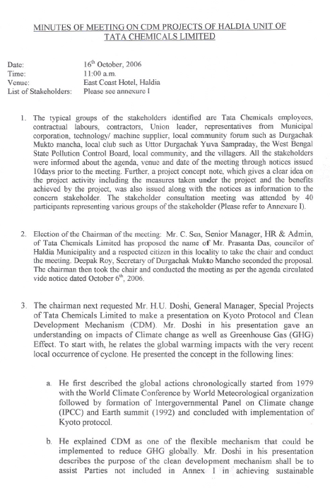

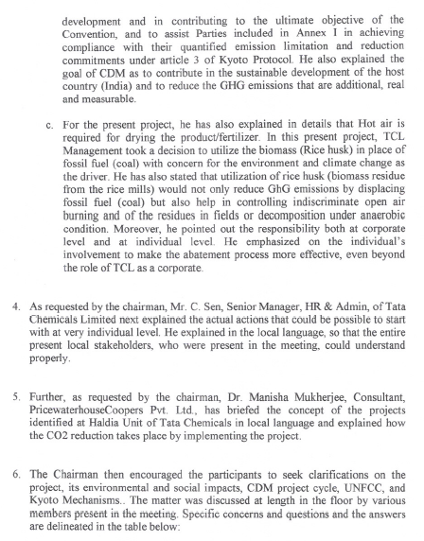

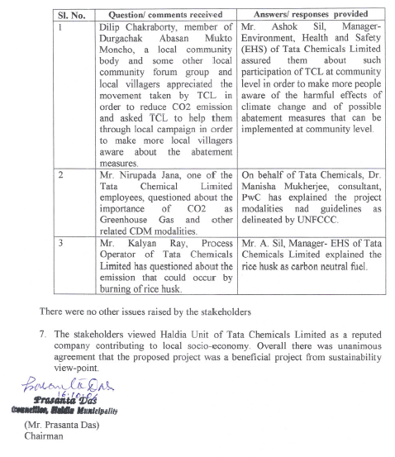

Exhibit A

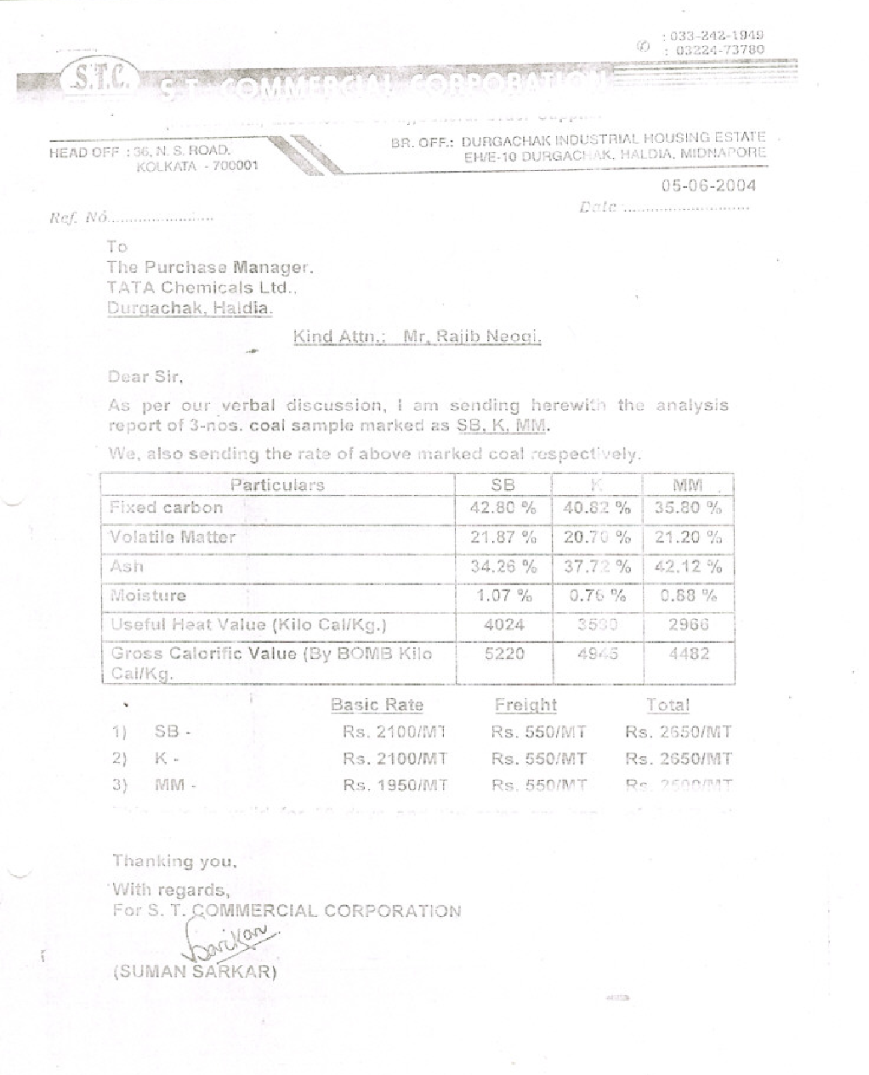

Exhibit B

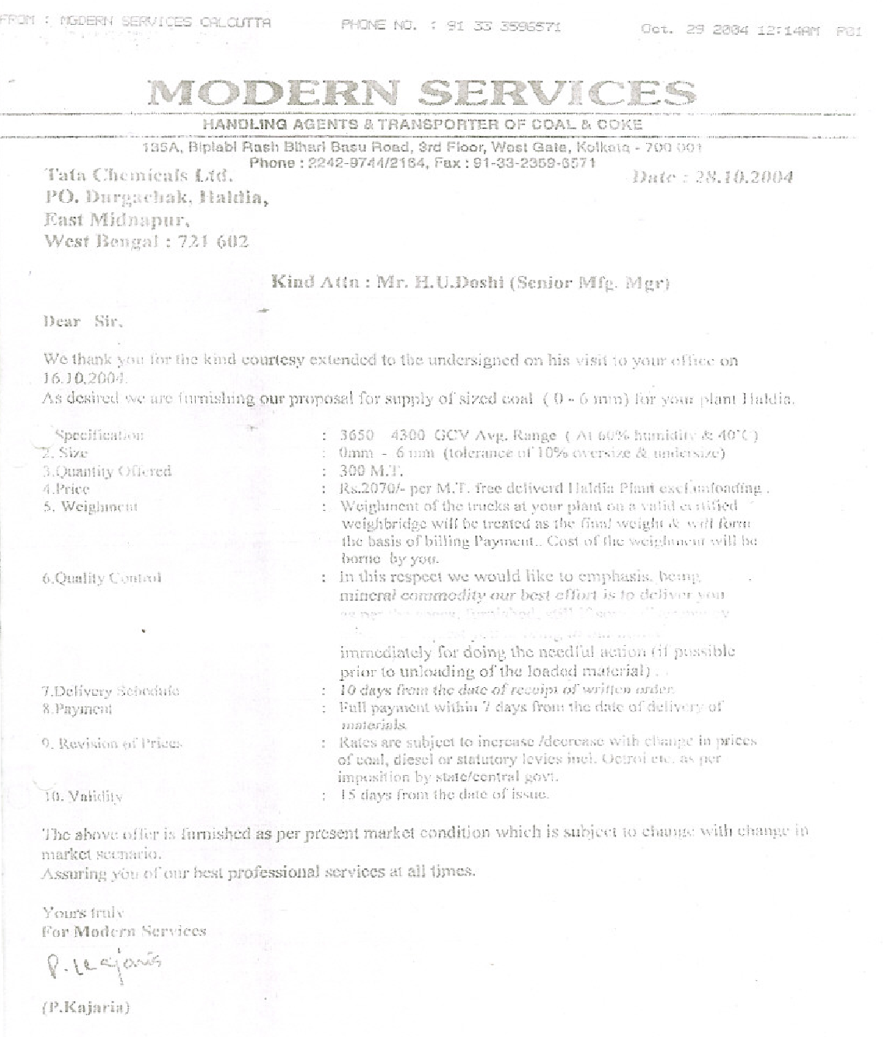

Exhibit C
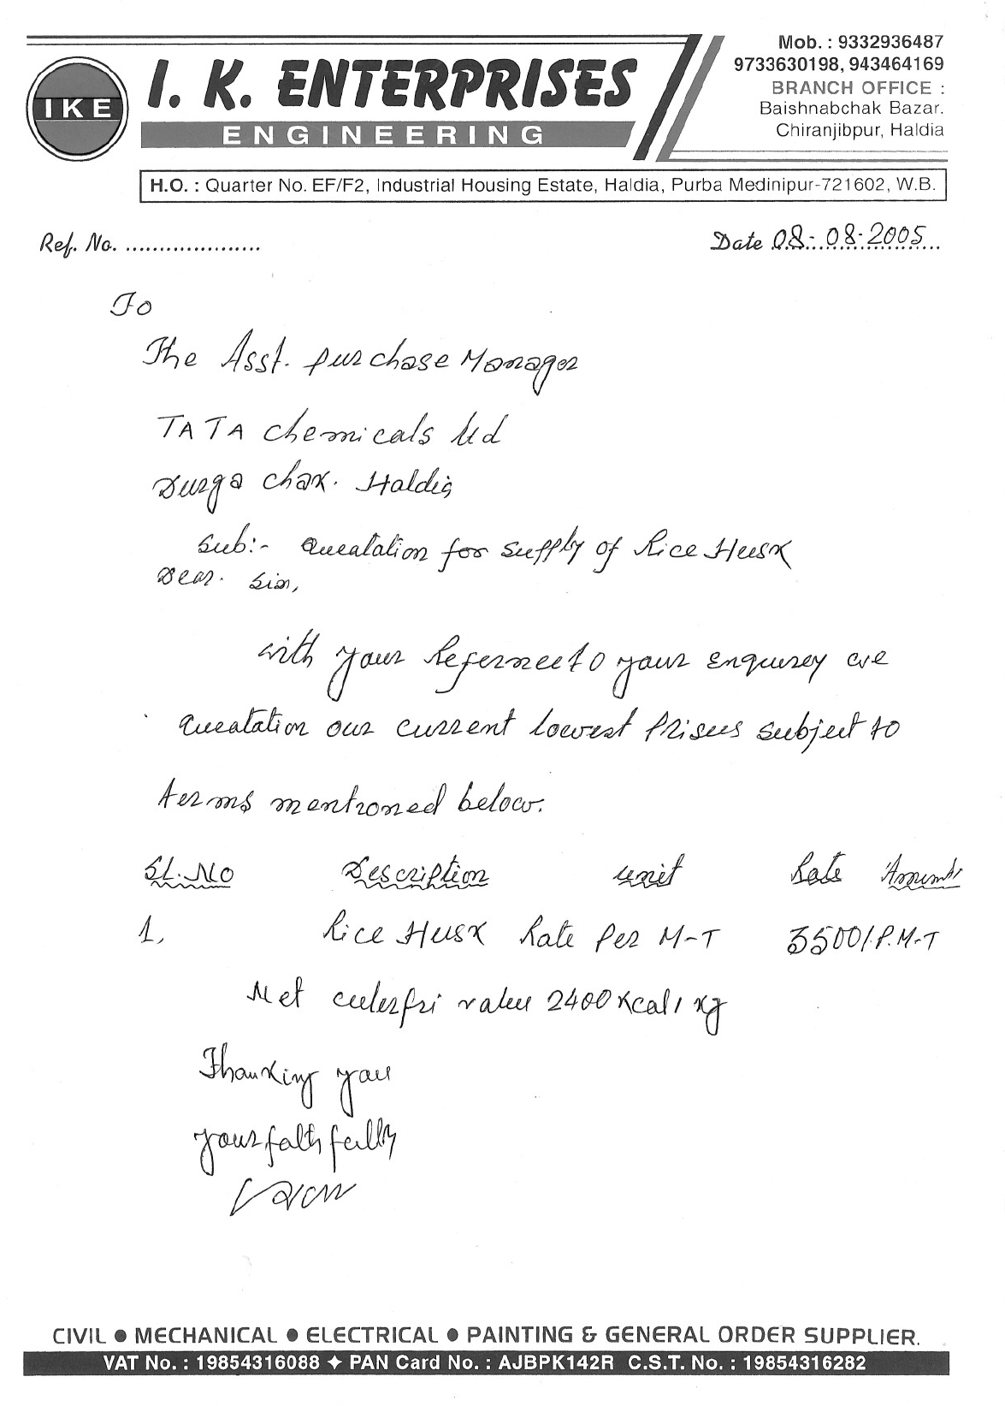

Exhibit D

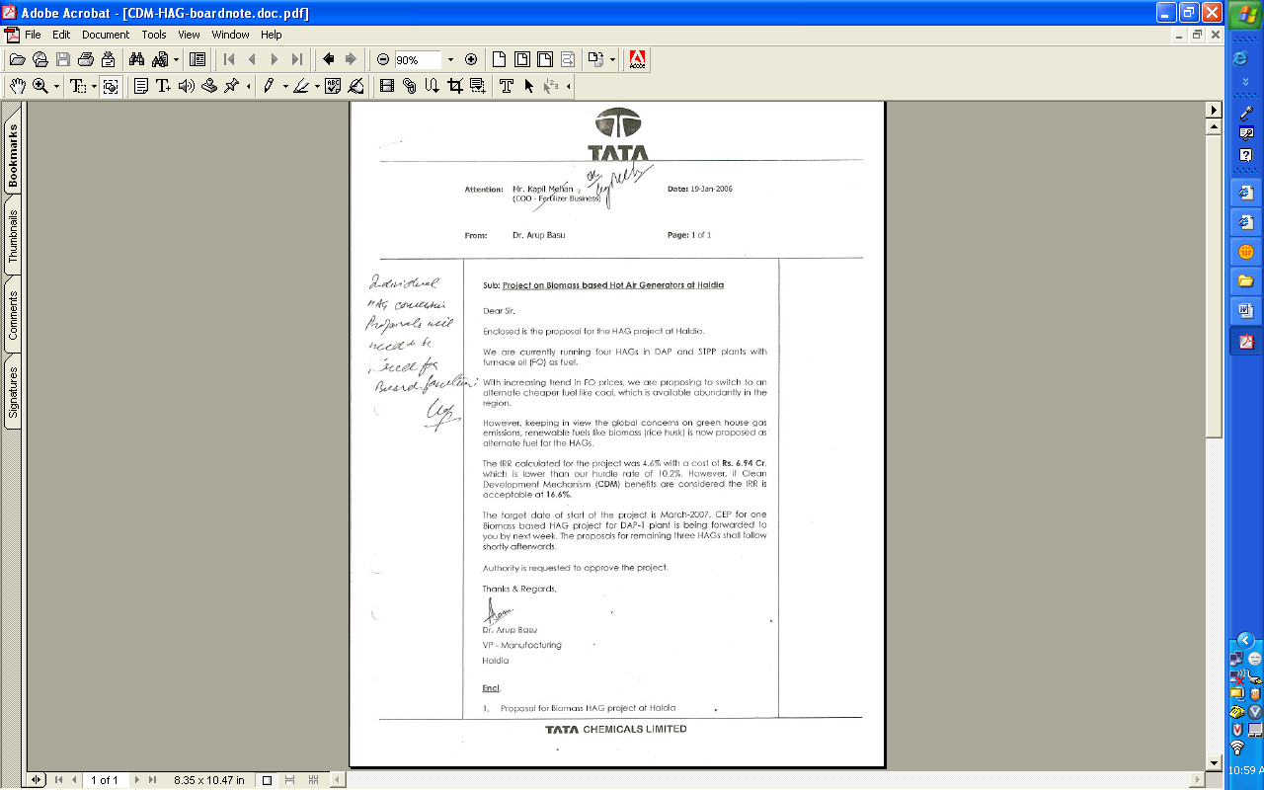
- - - - -

DAP: Di-ammonium phosphate STPP: Sodium tripoly phosphate
Purchase order placed on M/s I K Enterprise.
Source: Information from Ministry of Petroleum and Natural Gas, http://petroleum.nic.in/
Revised 2006 IPCC Guidelines for National Greenhouse Gas Inventories.

