2UNFCCC Secretariat
Martin-Luther-King-Strasse 8
D-53153 Bonn
Germany
Att: CDM Executive Board
Your ref.: | Our ref.: | Date:
CDM Ref 1613 | MLEH/ SSY | 10 June 2008

Response to requests for review
‘Yima Coal Industry (Group) Co., Ltd. CMM utilization project’ (1613)

Dear Members of the CDM Executive Board,
We refer to the issue raised by the requests for review by three Board members regarding project activity 1613 “Yima Coal Industry (Group) Co., Ltd. CMM utilization project” in China and would like to herewith provide our initial response to the issue raised.

Comment 1:
The monitoring of the methane destroyed by power and by heat (MD_{ELEC} and MD_{HEAT}), the relative proportion of NMHC compare to methane (r), the methane and NMHC concentrations (PC_{CH4} and PC_{NMHC}) should be included in section B.7.1. of the monitoring plan.
DNV Response:
The above parameters have been added to section B.7.1 of the monitoring plan in the revised PDD. By reviewing the revised part of the PDD,

Comment 2:
Individual monitoring and QA/QC procedures for each site should be presented in the PDD.
DNV Response:
QA/QC procedures have been added in the revised PDD. These monitoring and QA/QC procedures are appropriate to reflect the practice at each site and to ensure a reliable monitoring process.

Comment 3:
The DOE should clarify how it can be assured that the efficiency of methane oxidation in Vocsidizer (Eff_{HEAT}) will be maintained at the manufacturers specifications throughout the crediting period.
DNV Response:
It must be noted that DNV has assessed the project based on version 03 of ACM0008. This version does not give any detailed guidance on how to assure the efficiency of the methane destruction of the ventilation air methane. DNV acknowledges that version 04 of ACM0008 is more detailed with respect to assessing and monitoring the efficiency of methane oxidation of VAM.
DNV’s assessment of the efficiency of methane oxidation in vocsidizer is based on test reports for existing installations of the equipment. The test reports show that the oxidation efficiency remains within the range of 97.4% - 98.5% throughout the eight years test. The trends in these reports indicate that the efficiency of methane oxidation in vocsidizer (Eff_{HEAT}) will be maintained above 97% throughout the crediting period when the operations follow the manufacturer’s specifications. DNV was also able to confirm that the test results were representative and the design principle was reliable.
DNV acknowledges that monitoring of selected operational parameters would further assure that the efficiency of the methane oxidation is maintained,

We sincerely hope that the Board find our elaboration on the above satisfactory.
Yours faithfully
for Det Norske Veritas Certification AS
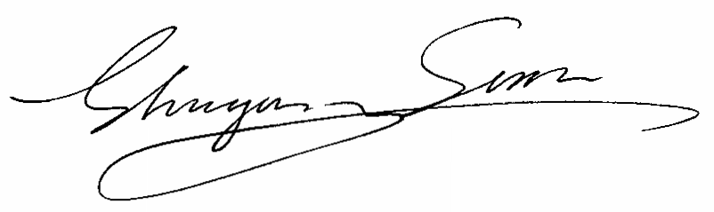
Michael Lehmann Mr. Shuyong Sun
Technical Director Project Manager
Climate Change Services

